REACT.JS

JavaScript library for building user interfaces
- HTML
- CSS
- JavaScript with ES6 preferably
- Basic understanding of how to use npm.

What is React?
- From the official React page : A JavaScript library for building user interfaces
- Its not a framework; React does only one thing – create awesome UI!
- React is used to build single page applications.
- React.js is a JavaScript library. It was developed by engineers at Facebook.
- React is a declarative, efficient, and flexible JavaScript library for building user interfaces.
- It lets you compose complex UIs from small and isolated pieces of code called
“components”.

- React : released by Facebook in 2013. By this point, FB had already been using React to solve many of its problems internally.
  - React itself is not technically a framework; it's a library for rendering UI components.
  - React is used in combination with other libraries to make applications — React and React
Native enable developers to make mobile applications; React and ReactDOM enable them to make
web applications, etc.

Components
- A Component is one of the core building blocks of React.
- Its just a custom HTML element!
  - Components are just HTML code, CSS code for styling and some JS code for logic
  - Advantages of components? Components are reusable, so same component can be used again and again in same UI
- Every application you will develop in React will be made up of pieces called components.
  - Components make the task of building UIs much easier. You can see a UI broken down into multiple individual pieces called components and work on them independently and merge them all in a parent component which will be your final UI.

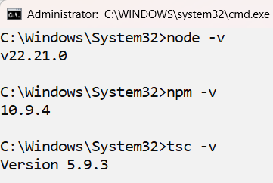
- Requirements
- Ensure that NodeJS and typescript are installed
  - You’ll need to have Node >= 22 on your local development machine
  - Install TypeScript as follows: npm install –g typescript

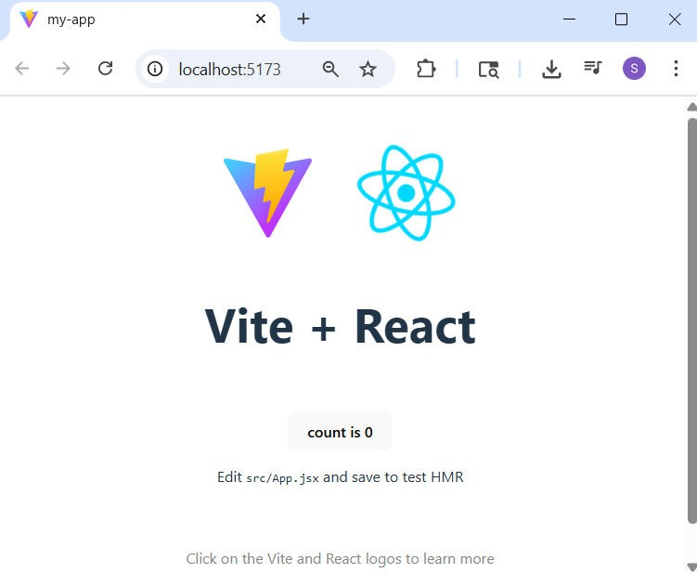
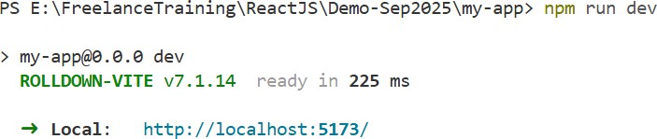
Using Vite
npm create vite@latest my-vite-react-app template react
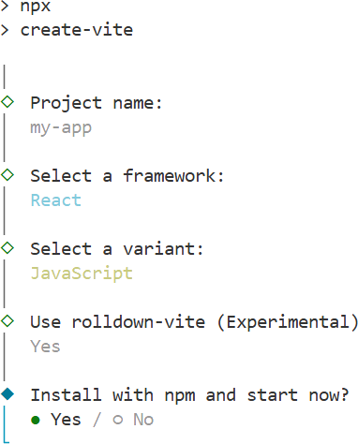
- Visit https://vite.dev/guide/ npm create vite@latest

Rolldown is a modern, high-performance JavaScript bundler written in Rust. It aims to provide significant performance improvements while maintaining compatibility with the existing ecosystem.

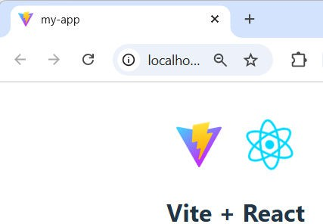
Understanding the folder structure
  - public/: This folder contains static assets that are served directly.
  - src/: This is where your React components and application logic reside. By default, you’ll
find an App.jsx and main.jsx.
  - index.html: The main HTML file that serves your application.
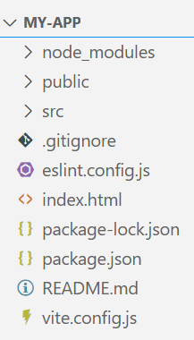
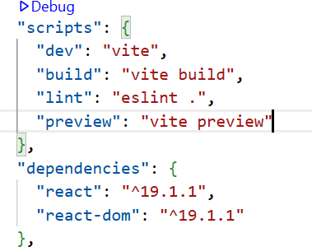
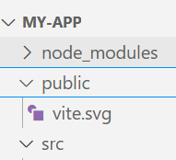
  - vite.config.js: This configuration file allows you to customize Vite’s behavior.

Index.html

<!doctype html>
<html lang="en">
<head>
<meta charset="UTF-8" />
To ensure proper rendering and touch zooming, add this <meta> tag
- The width=device-width part sets the width of the page to follow the screen-width of the device (which will vary depending on the device).
- The initial-scale=1 part sets the initial zoom level when the page is first loaded by
the browser.

<link rel="icon" type="image/svg+xml" href="/vite.svg" />
<meta name="viewport" content="width=device-width, initial-scale=1.0" />
<title>my-app</title>
</head>
<body>
<div id="root"></div>
<script type="module" src="/src/main.jsx"></script>
</body>
</html>
tells the browser to load the main JSX file as a module, which allows for modern JavaScript features and module imports to be used directly in the browser.

- The root node is the HTML element where you want to display the result.
- It is like a container for content managed by React.
- It does NOT have to be a <div> element and it does NOT have to have the id='root’

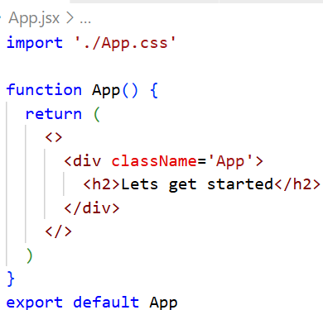
Understanding the folder structure
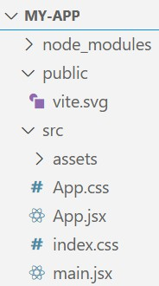
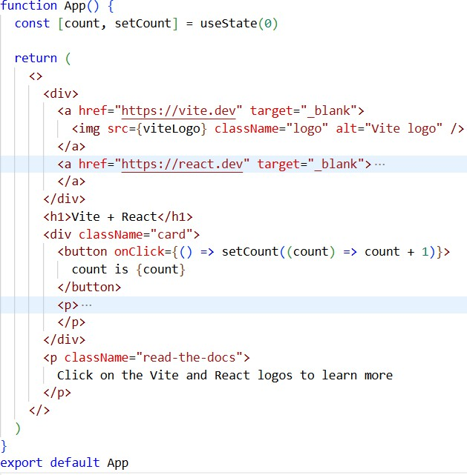
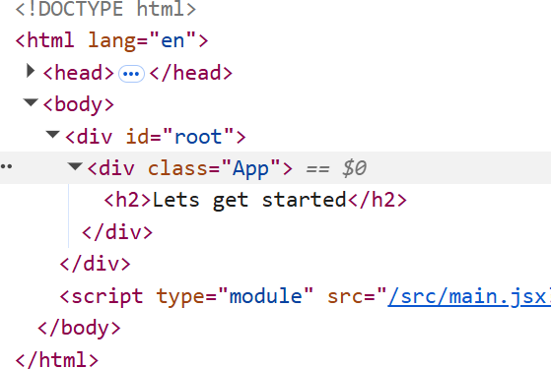
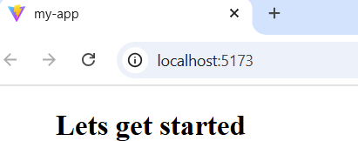
/* App.css */
.App {
margin-left: 50px;
}

Understanding JSX
  - Eg : const mytag = <h1>Hello React!</h1>;
const myelement = <h1>Understanding JSX!</h1>;

ReactDOM.render(myelement, document.getElementById('root'));

const myelement = (  <ul>  <li>Apples</li>  <li>Bananas</li> | To write HTML on multiple lines, put the HTML inside parentheses()
<li>Cherries</li>
</ul>
);
ReactDOM.render(myelement, document.getElementById('root'));

const myelement = (  <div>  <h1>I am a Header.</h1>  <h1>I am a Header too.</h1>  </div> | If we want to return more elements, we need to wrap it with one container element. Notice how we are using div as a wrapper for the two h1 elements.
);
ReactDOM.render(myelement, document.getElementById('root'));

JSX restrictions
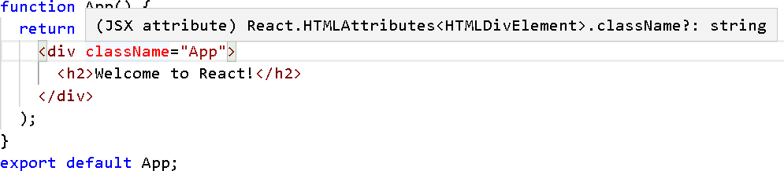
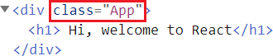

JSX clearly looks like HTML and it should allow us to write HTML-ish code in our JS file. But, since it is in a JS file and it IS a JS code, some words cant be used.
Eg, ‘class’ that we use normally use in HTML for bringing in CSS cant be used, since class is a ES6 feature too! And we can create React class components using “class” keyword

JSX vs. JavaScript (Only for Vite)
- The .js file is a file that contains standard JavaScript code.
  - These files do not contain the UI related code and are used for writing the logics and the functions.

    - Used for regular JavaScript code and logic.
    - Does not include JSX (HTML-like syntax).
    - Can be used for utility functions, state management, or simple React components.
    - No extra tools needed to run.

- JSX (JavaScript XML) is an extension of JavaScript that lets developers write HTML-like code inside JavaScript.
  - Files with the .jsx extension usually contain components written in JSX, which React then converts into JavaScript function calls.

    - Used for React components with JSX (HTML-like syntax).
    - Includes JSX to define the UI structure.
    - Mainly for creating and rendering the user interface.
    - Requires tools like Babel to convert JSX into JavaScript.

- Components are the essential building blocks of any app created with React
  - A single app most often consists of many components.
- A component is in essence, a piece of the UI - splitting the user interface into reusable and
independent parts, each of which can be processed separately.
  - Component is independent and reusable bit of code.
  - It’s an encapsulated piece of logic that returns HTML via a render function.
const ExpenseItem = () => {
return <h2>Expense Item</h2>
}
export default ExpenseItem;
function ExpenseItem(){
return <h2>Expense Item</h2>
}
export default ExpenseItem;

- Every React function component must follow 2 rules:
  - Function name MUST begin with capital
  - Function MUST return a “Renderable” value; ie return a value that can be rendered (displayed on screen) by React; typically returns JSX

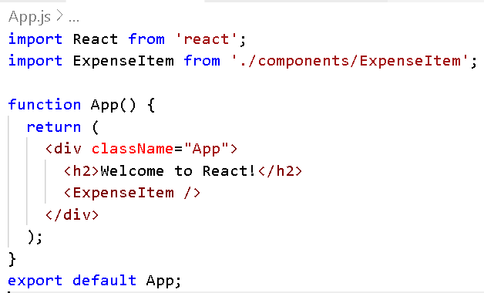
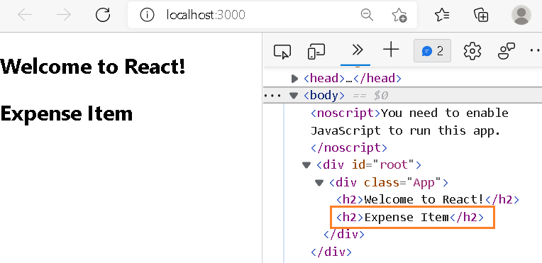
- Adding our component to main component
App

ExpenseItem ExpenseItem ExpenseItem

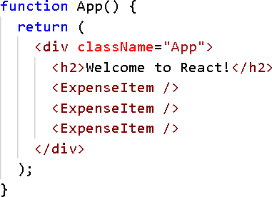
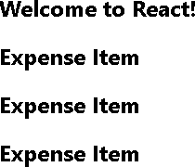
- Creating components makes them reusable and configurable.
- Reusing is simple. Eg, simply copy paste <ExpenseItem/> multiple times in App.js.

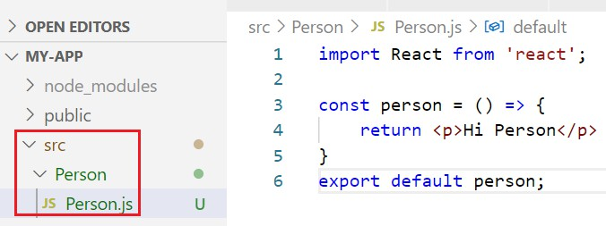
Another example
App
Person
Person
Person

import React, {Component} from 'react'; import './App.css';  import Person from './Person/Person'; function App() {  return (  <div className="App">  <h1> Hi, welcome to React</h1>  <Person />  </div>  );  }  export default App; | return (  <div className="App">  <h1> Hi, welcome to React</h1>  <Person />  <Person />  <Person />  </div>  );
 | 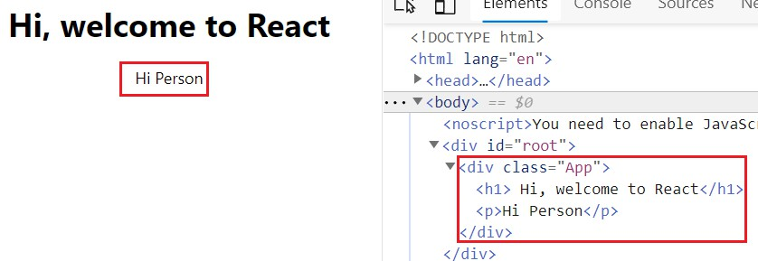

Components & JSX
- When creating components, you have the choice between two different ways:
- Functional components (also once referred to as "presentational", "dumb" or "stateless"
components)
const cmp = () => {
return <div>some JSX</div>
}
- class-based components (also referred to as "containers", "smart" or "stateful" components)
class Cmp extends Component { render () {
return <div>some JSX</div>
}
}

Making our functional component more complex
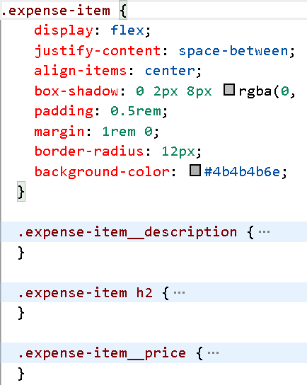
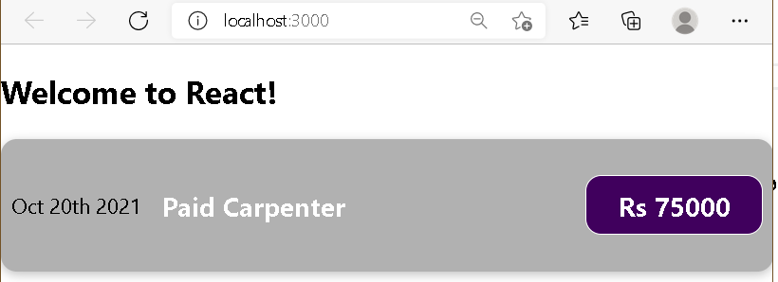
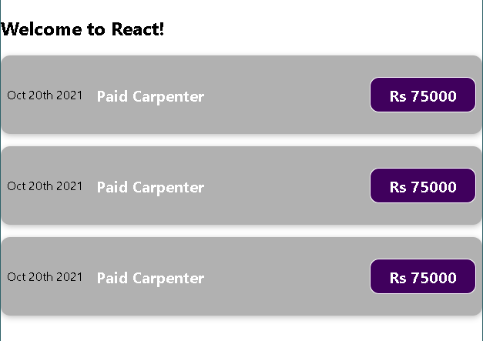
import "./ExpenseItem.css"

const ExpenseItem = () => {
return (
<div className="expense-item">
<div>Oct 20th 2021</div>
<div className="expense-item description">
<h2>Paid Carpenter</h2>
<p className="expense-item price">Rs 75000</p>
</div>
</div>
)
}
export default ExpenseItem;

Outputting dynamic content
- If we have some dynamic content in our jsx part which we want to run as javaScript code and not interpret as text, we have to wrap it in single curly braces.
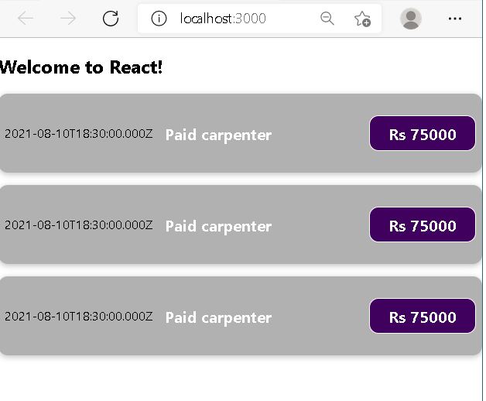
import "./ExpenseItem.css" const ExpenseItem = () => {
const expDate = new Date(2021, 7, 11); const expTitle = "Paid carpenter"; const expAmount = 75000
return (
<div className="expense-item">

{/* single and multiline comments in JSX */}

<div>{expDate.toISOString()}</div>
<div className="expense-item description">
<h2>{expTitle}</h2>

Comments in JSX

<p className="expense-item price">Rs {expAmount}</p>
</div>
</div>
)
} Wrap dynamic content in

export default ExpenseItem;
JSX in {...}

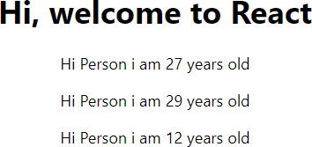
Outputting dynamic content – another example
Math.random() returns a random number between 0 and 1.
Math.floor(Math.random() * 30)) Returns a
random integer from 0 to 29
function App() { return (
<div className="App">
<h1> Hi, welcome to React</h1>
<Person />
<Person />
<Person />
</div>
);
}
}
//Person.js
const person = () => {
return <p>Hi Person i am {Math.floor(Math.random() * 30)} years old</p>
}
export default person;
Wrap dynamic content in JSX in {...}

PROPS

Passing data via ‘props’
- “props” stands for properties.
Parent component
Child component


  - It is a special keyword in React used for passing data from one component to another.
  - Props are arguments passed into React components.
  - props are read-only. So, the data coming from a parent component can't be changed by the child component.
  - Props are passed to components via HTML attributes.
  - Props can be used to pass any kind of data such as: String, Array, Integer, Boolean, Objects or, Functions
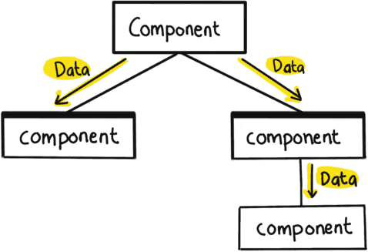
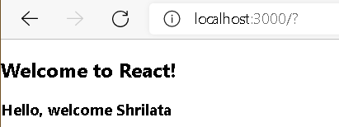
import HelloComponent from "./HelloComponent"; const MessageComponent = () => {
return(
<div>
<HelloComponent name="Shrilata" />
</div>
);
}
export default MessageComponent;
const HelloComponent = (props) => {
return (<h3>Hello, welcome {props.name}</h3>)
}
export default HelloComponent;

Passing data via ‘Props’

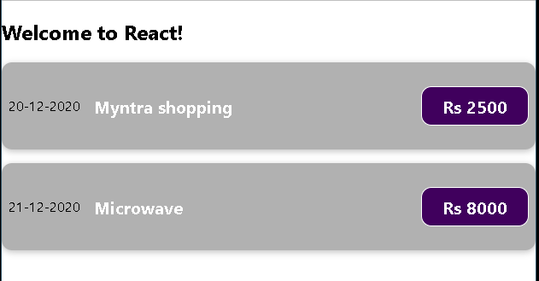
function App() { return (
<div className="App">
<h2>Welcome to React!</h2>
<ExpenseItem expDate="20-12-2020" expTitle="Myntra shopping" expAmount="2500"/>
<ExpenseItem expDate="21-12-2020" expTitle="Microwave" expAmount="8000"/>
</div>
);
}

export default App;
you can use as many props as you like

const ExpenseItem = (props) => { return (
<div className="expense-item">
<div>{props.expDate}</div>
<div className="expense-item description">
<h2>{props.expTitle}</h2>
<p className="expense-item price">Rs {props.expAmount}</p>
</div>
</div>
) React uses ‘props’ to pass attributes from ‘parent’
} component to ‘child’ component.
export default ExpenseItem;

Working with props
function App() { return (
<div className="App">
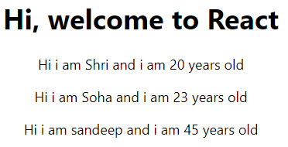
<h1> Hi, welcome to React</h1>
<Person name="Shri" age="20"/>
<Person name="Soha" age="23”>Hobbies : Coding</Person>
<Person name="sandeep" age="45"/>
</div>
);
//Person.js
import React from 'react';

const person = (props) => {
return <p>Hi i am {props.name} and i am {props.age} years old</p>
}
export default person;
React uses ‘props’ to pass attributes from ‘parent’
component to ‘child’ component.
const Person = ({name, age}) => {
return <p>Hi i am {name} and i am {age} years old</p>
}

If pros names match parent attributes, you can use object destructuring instead of “props”.

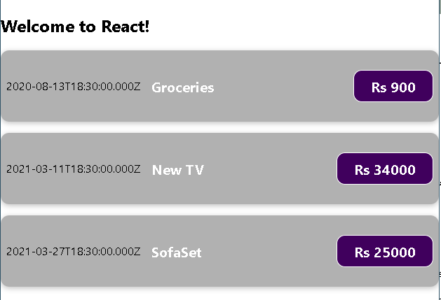
function App() { const expenses = [
{
title: 'Groceries',
amount: 900,
date: new Date(2020, 7, 14),
},
{ title: 'New TV', amount: 34000, date: new Date(2021, 2, 12) },
{ title: 'SofaSet', amount: 25000, date: new Date(2021, 2, 28),
}
];

return (
<div className="App">
<h2>Welcome to React!</h2>
<ExpenseItem expDate={expenses[0].date} expTitle={expenses[0].title} expAmount={expenses[0].amount}/>
<ExpenseItem expDate={expenses[1].date} expTitle={expenses[1].title} expAmount={expenses[1].amount}/>
<ExpenseItem expDate={expenses[2].date} expTitle={expenses[2].title} expAmount={expenses[2].amount}/>
</div>
);
}
export default App;

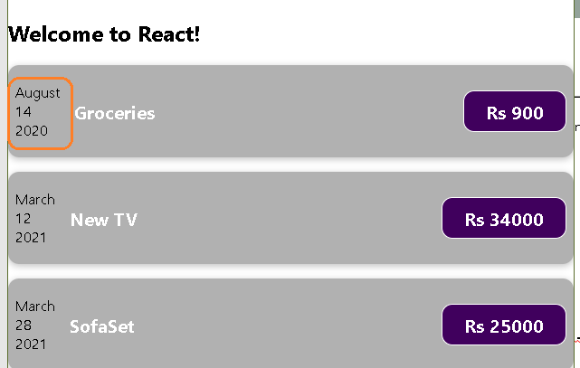
const ExpenseItem = (props) => {
const month = props.expDate.toLocaleString('en-US', {month: 'long'}); const day = props.expDate.toLocaleString('en-US', {day: '2-digit'}); const year = props.expDate.getFullYear();

return (
<div className="expense-item">
<div>
<div>{month}</div>
<div>{day}</div>
<div>{year}</div>
</div>
<div className="expense-item description">
<h2>{props.expTitle}</h2>
<p className="expense-item price">Rs{props.expAmount}</p>
</div>
</div>
)
}
export default ExpenseItem;

import ExpenseDate from "./ExpenseDate";
const ExpenseItem = (props) => { return (
<div className="expense-item">
<ExpenseDate date={props.expDate}/>

Splitting components further

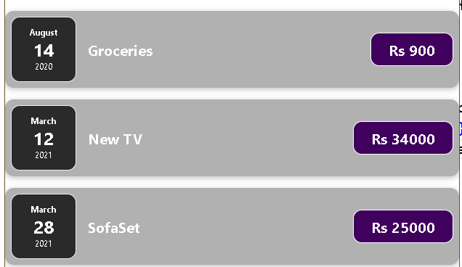
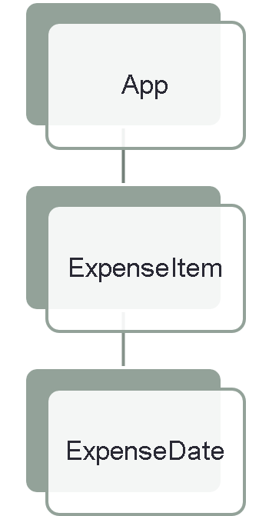
<div className="expense-item description">
<h2>{props.expTitle}</h2>
<p className="expense-item price">Rs {props.expAmount}</p>
</div>
</div>
)
}
export default ExpenseItem;

import "./ExpenseDate.css"

const ExpenseDate = (props) => {
const month = props.date.toLocaleString('en-US', {month: 'long'}); const day = props.date.toLocaleString('en-US', {day: '2-digit'}); const year = props.date.getFullYear();
return (
<div className="expense-date">
<div className="expense-date month">{month}</div>
<div className="expense-date day">{day}</div>
<div className="expense-date year">{year}</div>
</div>
);
}
export default ExpenseDate;

Splitting components
- As your application grows, it becomes even more crucial to divide it into smaller components.
- Each component should encapsulate a specific
part of the application's functionality.
  - These components should have a single responsibility, i.e., they should accomplish one thing only.
  - The benefit is that these components can be easily
reused and tested.

  - For instance, if you were to create a blog application, you might divide your app into components like Header, Footer, ArticleList, Article, Comment, and so on.

function Header() {
// ...Header implementation... }

function ArticleList() {
// ...ArticleList
implementation... }

function Article() {
// ...Article implementation... }

function Comment() {
// ...Comment implementation... }

function Footer() {
// ...Footer implementation... }

function Blog() { return (
<div>
<Header />
<ArticleList>
<Article />
<Comment />
</ArticleList>
<Footer />
</div>

);
}

EVENTS AND EVENT HANDLING

Listening to events and working with event handlers

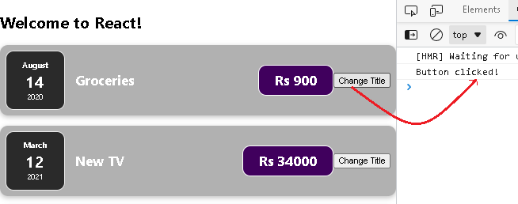
const ExpenseItem = (props) => {

let btnHandler = () => { console.log("Button clicked!")
}

return (
<div className="expense-item">
<ExpenseDate date={props.expDate}/>
<div className="expense-item description">
<h2>{props.expTitle}</h2>
<p className="expense-item price">Rs {props.expAmount}</p>
</div>
<button onClick={btnHandler}>Change Title</button>
</div>
)
}
export default ExpenseItem;

No parenthesis ()

STATEFUL COMPONENTS

React State
- The state is a built-in React object that is used to contain data or information about the component.
- A component’s state can change over time; whenever it changes, the component re-
renders.
  - The change in state can happen as a response to user action or system-generated events and these changes determine the behavior of the component and how it will render.
- A component with state is known as stateful component.

- State allows us to create components that are dynamic and interactive.
  - State is private, it must not be manipulated from the outside.
  - Also, it is important to know when to use ‘state’, it is generally used with data that is bound to
change.

Component without state

const ExpenseItem = (props) => { let title = props.expTitle;
let btnHandler = () => {
title = "updated expense" console.log("Button clicked!")
}

return (
<div className="expense-item">
<ExpenseDate date={props.expDate}/>
<div className="expense-item description">
<h2>{title}</h2>
<p className="expense-item price">Rs {props.expAmount}</p>
</div>
<button onClick={btnHandler}>Change Title</button>
</div>
)
}
export default ExpenseItem;

React Hooks
- React Hooks are special functions provided by React to handle a specific functionality inside a React functional component.
  - Hooks allow us to "hook" into React features such as state and lifecycle methods
  - React provides useState() function to manage state in a functional component.

- You must import Hooks from react
  - import React, { useState } from "react";
  - Here - useState is a Hook to keep track of the application state.

- There are some rules for hooks:
  - Hooks can only be called inside React function components.
  - Hooks can only be called at the top level of a component.
  - Hooks cannot be conditional
  - Hooks will not work in React class components.
  - If you have stateful logic that needs to be reused in several components, you can build your own custom Hooks

- The React useState Hook allows us to track state in a function component.
- To use the useState Hook, we first need to import it into our component.
  - import { useState } from "react";
  - We initialize our state by calling useState in our function component.
import React, {useState} from 'react';

const UseStateComponent = () => {
useState(); //hooks go here
}
  - useState accepts an initial state and returns two values:
- The current state.
- A function that updates the state.
  - Eg:
function FavoriteColor() {
const [color, setColor] = useState(“white");
}

    - The first value, color, is our current state.
    - The second value, setColor, is the fuction that is used to update our state.
    - Lastly, we set the initial state to a white color: useState(“white")

import React, {useState} from 'react';

const UseStateComponent = () => {
const [counter, setCounter] = useState(0); //hooks go here

const btnHandler = () => { setCounter(counter+1); console.log(counter, " button clicked")
}
return(
<div>
Counter : {counter} &nbsp;&nbsp;
<button onClick={btnHandler}>increment counter</button>
</div>
);
}
export default UseStateComponent;
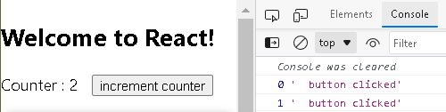

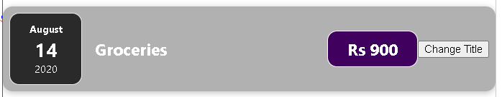
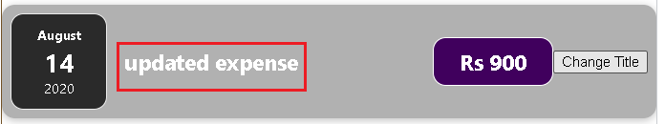
import React, {useState} from 'react' const ExpenseItem = (props) => {
const [title, setTitle] = useState(props.expTitle);

let btnHandler = () => { setTitle("updated expense") console.log("Button clicked!")
}

return (
<div className="expense-item">
<ExpenseDate date={props.expDate}/>
<div className="expense-item description">
<h2>{title}</h2>
<p className="expense-item price">Rs {props.expAmount}</p>
</div>
<button onClick={btnHandler}>Change Title</button>
</div>
)
}
export default ExpenseItem;

props and state
- props and state are CORE concepts of React.
- Actually, only changes in props and/ or state trigger React to re-render your components and
potentially update the DOM in the browser
- Props : allow you to pass data from a parent (wrapping) component to a child component.
- State : State is used to change the component’s state from within.
  - Changes to state also trigger an UI update.

- Props are immutable; once placed, they cannot be altered.
- Props data are read-only, so children of elements cannot change their parents’ data
- Data and event handlers are passed to the child components using props.
- They are owned by the component which passes them to some other component.
- The data of the components that must be presented to the view is stored in State
- State is something internal and private to the component.
- State can and will change depending on the interactions with the outer world.
- State should store as simple data as possible, such as whether an input checkbox is checked or not or a CSS class that hides or displays the component

import React, {useState} from 'react'
import ChildComponent from './ChildComponent';

const ParentComponent = () => {
const [uname, setUname] = useState('Shrilata')
const [email, setEmail] = useState('shrilata@gmail.com')

Simple example : props + state

return(
<ChildComponent uname={uname} email={email} />
);
}
function App() { return (
<div className="App">
<h2>Welcome to React!</h2>

export default ParentComponent;

const ChildComponent = (props) => { return(
<div>
<div>Name : {props.uname}</div>
<div>Email : {props.email}</div>
</div>

...
<ParentComponent />

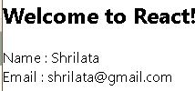
);
}
export default ChildComponent;

USING FORM FOR INPUT

React forms
- Forms are a crucial component of React web applications.
  - They allow users to directly input and submit data in components ranging from a login screen to a checkout page.
  - Since most React applications are single page applications (SPAs), or web applications that load a single page through which new data is displayed dynamically, you won’t submit the information directly from the form to a server.
  - Instead, you’ll capture the form information on the client-side and send or display it using additional JavaScript code.

To add bootstrap to style our form easily:
- npm install bootstrap –save
- Import Bootstrap CSS in the beginning of the src/index.js file (main.jsx in Vite)
import React from 'react';
import ReactDOM from 'react-dom/client';
import App from './App';
import 'bootstrap/dist/css/bootstrap.css';

const root = ReactDOM.createRoot(document.getElementById('root')); root.render(
<React.StrictMode>
<App />
</React.StrictMode>
);

Simple form demo (without Bootstrap)

import { useState } from "react" let SimpleForm = ()=>
let [uname, setUname] = useState("")

let unameHandler = (event)=>{ setUname(event.target.value)
}  let submitHandler = (event) => {  event.preventDefault(); | 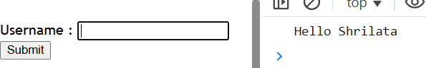
console.log("Hello",uname) setUname("")
}

return(
<form onSubmit={submitHandler}>
Username : <input onChange={unameHandler} value={uname} /><br />
<input type="submit" />
</form>
)
}
export default SimpleForm

SimpleInput.js (with Bootstrap)
const SimpleInput = (props) => {

const [inputName, setInputName] = useState('')
function App() { return (
<div className="App">
<h1>Working with forms</h1>
<SimpleInput />
</div>
);

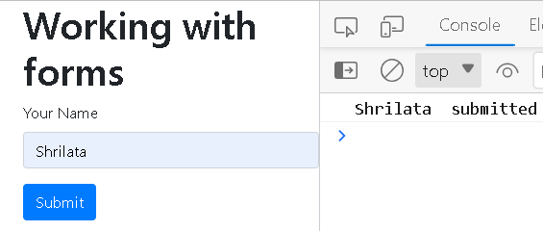
const inputNameHandler = (event) => { }
setInputName(event.target.value)
}

const formSubmitHandler = event => { event.preventDefault(); console.log(inputName, " submitted")
}
return (
<form onSubmit={formSubmitHandler}>
<div className='form-group'>
<label htmlFor='name'>Your Name</label>
<input type='text' name='uname' className='form-control' onChange={inputNameHandler}/>
</div>
<div className="form-actions">
<button className="btn btn-primary">Submit</button>
</div>
</form>
);
};

SimpleForm with inline styling
let SimpleFormWithInBuiltStyle = () => {
...
const styles = { heading: {
fontWeight: 'bold', fontSize: '25px', color: "green", textAlign: "center",

return (
<div>
<h1 style={styles.heading}>Welcome to forms</h1>
<h3 style={styles.subHeading}>User Input </h3>
<form onSubmit={submitHandler} style={styles.form}> Username : <input onChange={unameHandler}
style={styles.input}
value={uname} /><br />
<input type="submit"
style={{ ...styles.button}}/>
</form>
</div>
)
}
},
subHeading: {
fontWeight: 'bold', fontSize: '25px', textAlign: "center",
},
form: {
backgroundColor: '#fff', padding: '20px', borderRadius: '8px', boxShadow: '0 2px 4px
rgba(0, 0, 0, 0.1)',
width: '100%', maxWidth: '400px', margin: '0 auto',

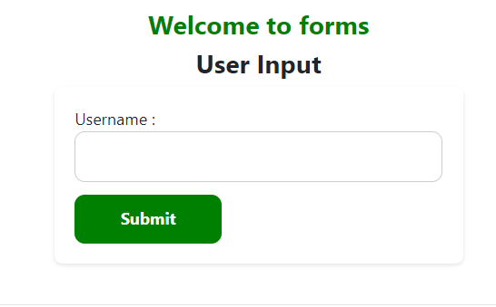
},
...
};

import { useState } from "react" let SimpleForm1 = ()=>{
let [uname, setUname] = useState("") let [gender, setGender] = useState("")

Example-2 : SimpleInput1.js with multiple form elements

let unameHandler = (event)=>{
setUname(event.target.value)
}

let genderHandler = (event)=>{ setGender(event.target.value)
}

let submitHandler = (event) => { event.preventDefault(); let user = {
uname : uname, gender : gender
}
console.log(user)
return(
<form onSubmit={submitHandler}>
Username : <input onChange={unameHandler}
value={uname} /><br />
Gender:
<select onChange={genderHandler}
value={gender}>
<option value="male">Male</option>
<option value="female">Female</option>
</select> <br />
<input type="submit" />
</form>
)
}

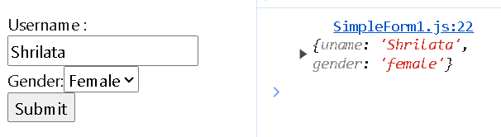
setUname("")
setGender("")
}

const UserRegForm = () => {
const initValues = {uname:"", email:"", password:""} const [formValues, setFormValues] = useState(initValues)

let handleChange = (e) => {
const {name, value} = e.target setFormValues({...formValues,[name]:v
alue})

Example-3 : form with multiple form elements

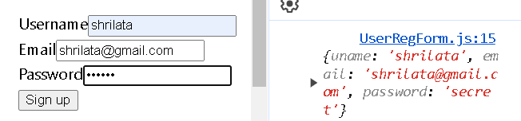
}

let submitHandler = (event) => { event.preventDefault() console.log(formValues)
setFormValues({uname:"", email:"", password:""})
}
return (
<form onSubmit={submitHandler}>
<label htmlFor="uname">Username</label>
<input name="uname" value={formValues.uname} onChange={handleChange}/>
<label htmlFor="email">Email</label>
<input type="email" name="email" value={formValues.email} onChange={handleChange}/>
<label htmlFor="password">Password</label>
<input type="password" name="password" value={formValues.password}
onChange={handleChange}/>
<button type="submit">Sign up</button>
</form>
);}

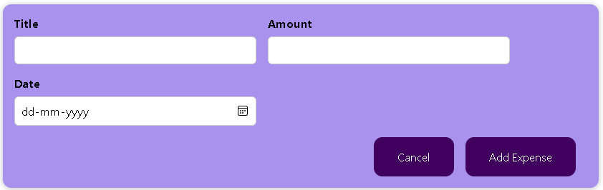
import "./ExpenseForm.css" const ExpenseForm = () => {
Adding form inputs
return(
<form>

const NewExpense = () => { return(
<div className="new-expense">
<ExpenseForm />
</div>
);
}
export default NewExpense;

}
<div className="new-expense controls">
<div className="new-expense control">
<label>Title</label>
<input />
</div>
<div className="new-expense control">
<label>Amount</label>
<input type="number"/>
</div>
<div className="new-expense control">
<label>Date</label>
<input type="date" />
</div>
</div>
<div className="new-expense actions">
<button type="submit">Add Expense</button>
</div>
</form>
);

export default ExpenseForm;

Listening to user input in our tracking application
const ExpenseForm = () => {

const titleChangeHandler = (event) => {
console.log(event.target.value)
We want to store the extracted form info somewhere

}
return(
<form>
<div className="new-expense controls">
<div className="new-expense control">
<label>Title</label>
<input onChange={titleChangeHandler}/>
</div>
...
</div>
<div className="new-expense actions">
<button type="submit">Add Expense</button>
</div>
</form>

One way to ensure the value is stored and make sure that the value survives even if the component is re-executed is to use state

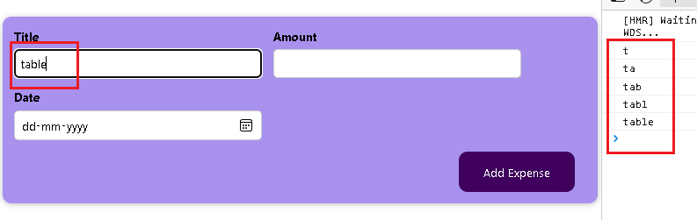
);
}
export default ExpenseForm;

Storing input into state – working with multiple states

import React, {useState} from 'react';
const ExpenseForm = () => {  const [inputTitle, setInputTitle] = useState('') const [inputAmount, setInputAmount] = useState('') const [inputDate, setInputDate] = useState('') | Notice that we are dealing with multiple states which is normal in React.  However, we can also have just one state
const titleChangeHandler = (event) => { setInputTitle(event.target.value)
}
const amountChangeHandler = (event) => { setInputAmount(event.target.value)
}
const dateChangeHandler = (event) => { setInputDate(event.target.value)
}
return(
<form>
<div className="new-expense controls">
<div className="new-expense control">
<label>Title</label> <input onChange={titleChangeHandler}/>
</div>
<div className="new-expense control">
<label>Amount</label>
<input type="number" onChange={amountChangeHandler}/>
</div> ...

Form submission
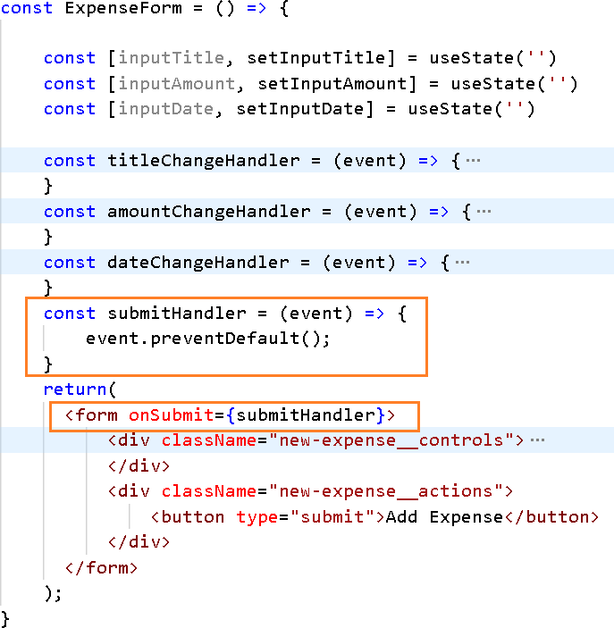

Form submission – extracting data, 2-way binding
const ExpenseForm = () => {

const [inputTitle, setInputTitle] = useState('') const [inputAmount, setInputAmount] = useState('') const [inputDate, setInputDate] = useState('')

const titleChangeHandler = (event) => {earlier-code} const amountChangeHandler = (event) => {earlier-code} const dateChangeHandler = (event) => {...}

const submitHandler = (event) => { event.preventDefault();
const expenseData = { title:inputTitle, amount:inputAmount,
date: new Date(inputDate)
}
console.log(expenseData)

setInputAmount('') setInputDate('') setInputTitle('')
}

return(
<form onSubmit={submitHandler}>
<div className="new-expense controls">
<div className="new-expense control">
<label>Title</label>
<input value={inputTitle} onChange={titleChangeHandler}/>
</div>
...
</form>
);

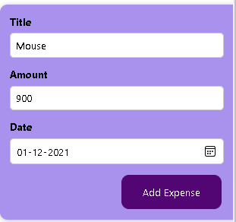
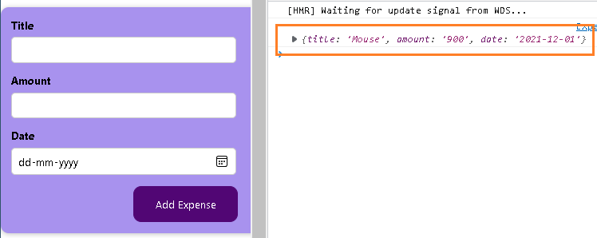
}

const NewExpense = () => {
const saveExpenseDataHandler = (inputExpenseData) => { const expenseData = {
...inputExpenseData, id:Math.random().toString()
}
console.log("In NewExpense ",expenseData)

Passing data from child to parent

}
return(
<div className="new-expense">
<ExpenseForm onSaveExpenseData={saveExpenseDataHandler}/>
</div>
); const ExpenseForm = (props) => {
} ...

export default NewExpense;
const submitHandler = (event) => {
event.preventDefault(); const expenseData = {
title:inputTitle, amount:inputAmount, date:inputDate

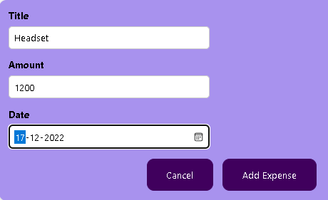
}
//console.log(expenseData) props.onSaveExpenseData(expenseData);
...
}

function App() {
const expenses = [...];

const addExpenseHandler = expense => {
console.log("In App component ", expense)
}

return (
<div className="App">
<h2>Welcome to React!</h2>
<NewExpense onAddExpense={addExpenseHandler} />
...
);
} const NewExpense = (props) => {

export default App;
const saveExpenseDataHandler = (inputExpenseData) => { const expenseData = {
...inputExpenseData, id:Math.random().toString()

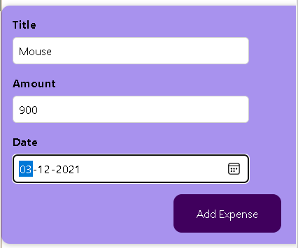
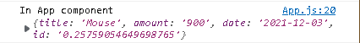
}
//console.log("In NewExpense ",expenseData) props.onAddExpense(expenseData)
}
return(...);
}
export default NewExpense;

- In a typical application, you pass a lot of state down to child components as props.
  - These props are often passed down multiple component levels.
  - That's how state is shared vertically in your application.
- Often there will be a need to share state between different components.
  - The common approach to share state between two components is to move the state to common parent of the two components.
  - This approach is called as lifting state up in React.js
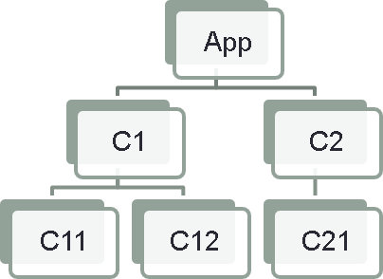
  - React components can manage their own state
  - Often components need to communicate state to others
  - Siblings do not pass state to each other directly
  - State should pass through a parent, then trickle down

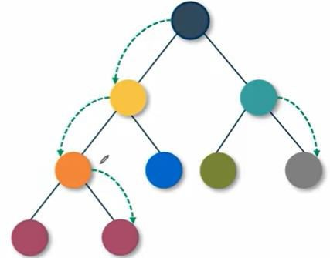
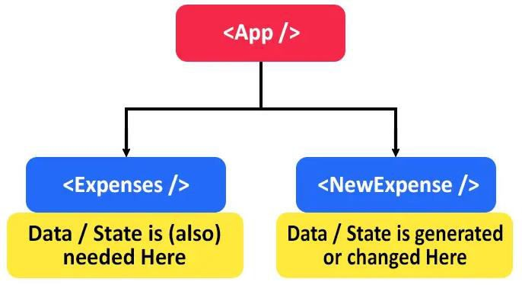

import React, {useState} from 'react'
import ChildComponent from './ChildComponent';

const ParentComponent = () => {
const [uname, setUname] = useState('Shrilata')
const [email, setEmail] = useState('shrilata@gmail.com')

return(
<ChildComponent uname={uname} email={email} />
);
} function App() {

export default ParentComponent;

const ChildComponent = (props) => { return(
<div>
<div>Name : {props.uname}</div>
<div>Email : {props.email}</div>
</div>
return (
<div className="App">
<h2>Welcome to React!</h2>
<ParentComponent />
...

);
}
export default ChildComponent;

import React, {useState} from 'react' import Display from './Display' import Button from './Button'

const ClickCounter = () => {
const [counter, setCounter] = useState(0)

const incrCounter = () => { setCounter(counter + 1)
}
return(
<div>
const Display = (props) => {
return <p>{props.message}</p>;
}
export default Display;

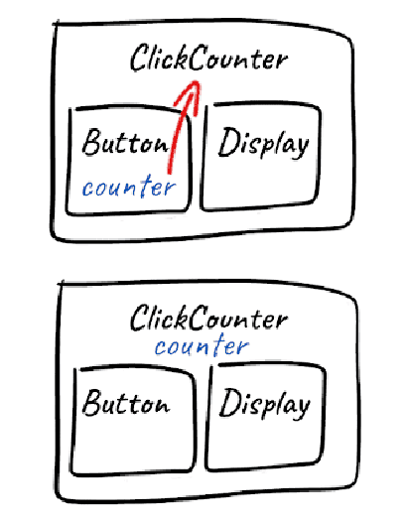
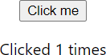
<Button onClick={incrCounter}>Button</Button>
<Display message={`Clicked ${counter} times`}/>
</div>
); The onClick here is a user defined
} prop, not an actual event
export default ClickCounter;

export default Button;
This is an actual event
const Button = (props) => {
return <button onClick={props.onClick}>Click me</button>;
}

WORKING WITH LISTS AND CONDITIONALS

Working with Lists
- Lists are very useful when it comes to developing the UI of any website.
  - Lists are mainly used for displaying menus on a website, for example, the navbar menu.
  - In regular JavaScript, we can use arrays for creating lists. We can create lists in React in a similar
manner as we do in regular JavaScript.
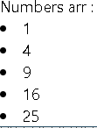
const ListComponent = () => {
let arr = [1,2,3,4,5]

let updatedArr = arr.map(num => { return <li>{num*num}</li>
})

return (
<div>
Numbers arr : {updatedArr}
</div>
)
}
export default ListComponent

const SimpleListComponent = () => { const nums = [1,2,3,4,5]
const updatedNums = nums.map((num)=>{ return <li>{num*num}</li>;
});

const items =[{name:'Item-1'}, {name:'Item-2'}] const updatedItems = items.map(item => (
<p>{item.name}</p>

Working with lists

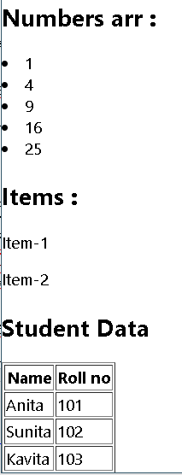
))

const students = [{name:"Anita",rollno:101},
{name:"Sunita",rollno:102},
{name:"Kavita",rollno:103}] const updatedStudents = students.map(student => (
<tr>
<td>{student.name}</td><td>{student.rollno}</td>
</tr>
))
return(
<div>
<h2> Numbers Arr: </h2> {updatedNums}
<h2> Items : </h2> {updatedItems}
<h2> Students Data</h2>
<table border="1">
<tr><th>Name</th><th>Roll no</th></tr>
{updatedStudents}</table>
</div>
);}
export default SimpleListComponent

import SimpleListChildComponent from "./SimpleListChildComponent";

const SimpleListComponent = () => {
const nums = [1,2,3,4,5]
const items =[{name:'Item-1'}, {name:'Item-2'}] const students = [{name:"Anita",rollno:101},
{name:"Sunita",rollno:102},
{name:"Kavita",rollno:103}]

return(
<div>
<SimpleListChildComponent nums={nums} items={items} students={students} />
</div>
);
}
export default SimpleListComponent
const SimpleListChildComponent = (props) => { const nums = props.nums;
const updatedNums = nums.map(...);
const items = props.items
const updatedItems = items.map(...)

const students = props.students;
const updatedStudents = students.map(...)

return(...);
}

export default SimpleListChildComponent;

Working with the expenses list

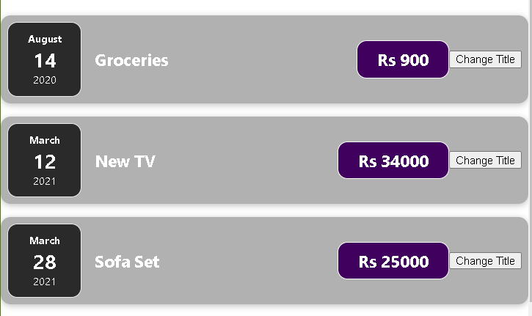
function App() { const expenses = [
{ title: 'Groceries', amount: 900, date: new Date(2020, 7, 14)},
{ title: 'New TV', amount: 34000, date: new Date(2021, 2, 12) },
{ title: 'Sofa Set', amount: 25000, date: new Date(2021, 2, 28)}

];
return (
<div className="App">
<h2>Welcome to React!</h2>

{expenses.map(expense => { return <ExpenseItem
expDate={expense.date} expTitle={expense.title} expAmount={expense.amount}
/>

{expenses.map(expense =>
(<ExpenseItem
expDate={expense.date} expTitle={expense.title} expAmount={expense.amount}
/>))
}

})}
{/* <ExpenseItem expDate={expenses[0].date} expTitle={expenses[0].title} expAmount={expenses[0].amount}
/> ... */}
</div>
);
}
export default App;

const DUMMY_EXP = [
{ title: 'Groceries', amount: 900, date: new Date(2020, 7, 14)},
{ title: 'New TV', amount: 34000, date: new Date(2021, 2, 12) },

Using stateful lists

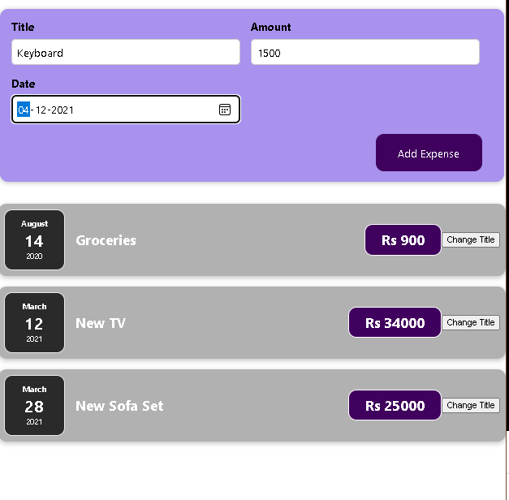
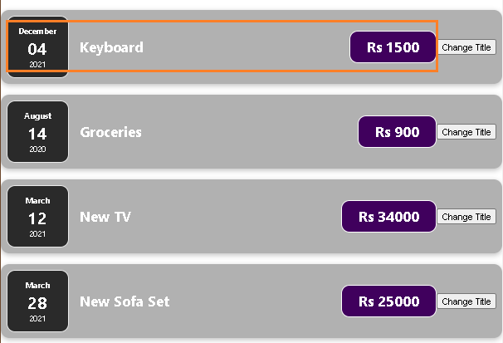
{ title: 'New Sofa Set', amount: 25000, date: new Date(2021, 2, 28)}
];
function App() {
const [expenses, setExpenses] = useState(DUMMY_EXP)

const addExpenseHandler = expense => {
//console.log("In App component ", expense) setExpenses(prevArr => {return [expense, ...prevArr]})
}
return (
<div className="App">
<h2>Welcome to React!</h2>
<NewExpense onAddExpense={addExpenseHandler} />

{expenses.map(expense => (<ExpenseItem expDate={expense.date} expTitle={expense.title} expAmount={expense.amount}
/>))
}
</div>
);
}
export default App;

Lists and keys
- When creating a list in JSX, React may show you an error and ask for a key.
  - Keys are unique identifiers that must be attached to the top-level element inside a map.
  - React uses keys to know how to update a list- whether adding, updating, or deleting items.
  - This is part of how React is so fast with large lists.
  - Keys are a way to help React know how to efficiently update a list.
  - We can add a key using the key prop like so:
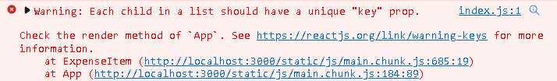
<ul>
{[1,2,3].map(no => <li key={no}>{no}</li>)}
</ul>
<div>
{people.map(person => (
<p key={person.name}>{person.name}</p>
))}
</div>
<li key={`${somevar}`} ...>

Lists and keys

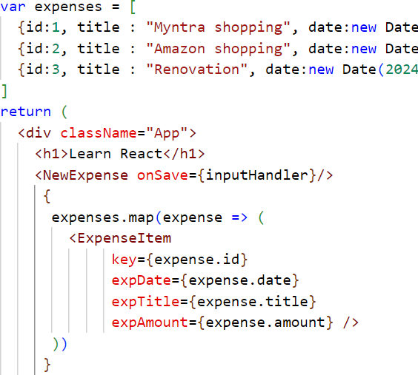
- Each list item in a list should have a unique
key.
- A “key” is a special string attribute you need to include when creating lists of elements in React.
- Keys allow React to keep track of elements. This way, if an item is updated or removed, only that item will be re-rendered instead of the entire list.
- key property to enable React to keep track of elements, so that it has a clear property that it can compare between the elements - to find out which elements changed and which didn’t - so that it only renders the elements that changed and not the whole list.

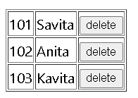
let ListComponent = () => { var personarr = [
{ pid: 101, pname: "Savita" },
{ pid: 102, pname: "Anita" },
{ pid: 103, pname: "Kavita" }

Deleting ExpenseItem from list

]
let [persons, setPersons] = useState(personarr)

let deleteHandler = pid => {
setPersons(oldarr => oldarr.filter(person => person.pid !== pid))
}
return (
<div>
<table border="1">
{persons.map(p => (
<tr key={p.pid}>
<td>{p.pid}</td><td>{p.pname}</td>
<td><button onClick={() => deleteHandler(p.pid)}>delete</button></td>
</tr>
))}
</table>
</div>
)}
export default ListComponent

function App() {
...
let deleteHandler = (id) => {

Deleting ExpenseItem from list

console.log("item to be deleted", id) setExpenses(oldValues => {
return oldValues.filter(item => item.expTitle !== id)
})
} //expenseItem.css

return (
...
{ expenses.map(expense => (
<ExpenseItem key={expense.id}
...
onDelete={deleteHandler} />
))}

let ExpenseItem = (props)=>{ return (
<div className="expense-item">
...
<button className=“delete-button"
.delete-button { display: flex;
flex-direction: column; width: 5.5rem;
height: 2.5rem;
border: 1px solid #ececec; background-color: red; color: white;
border-radius: 12px; align-items: center; justify-content: center;
}

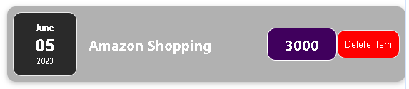
onClick={()=>props.onDelete(props.expTitle)}>Delete Item</button>
</div>)}

CONDITIONAL RENDERING

Rendering content conditiona ly

Conditional rendering means to render a specific HTML element or React component depending on a prop or state value.
  - In a conditional render, a React component decides based on one or several conditions which DOM elements it will return.
  - For instance, based on some logic it can either return a list of items or a text that says "Sorry, the list is
empty".
if(condition_is_met) { renderSectionOfUI();
}

- Consider these two components:
function Greeting(props) {
const isLoggedIn = props.isLoggedIn; if (isLoggedIn) {
return <UserGreeting />;
}
return <GuestGreeting />;
}
function UserGreeting(props) {
return <h1>Welcome back!</h1>;
}
function GuestGreeting(props) {
return <h1>Please sign up.</h1>;
}
  - Lets create a Greeting component that displays either of these components depending on whether a user is logged in:

Rendering content conditiona ly : example-1
/*const users = [  { id: '1', firstName: 'Shrilata', lastName: 'T' },  { id: '2', firstName: 'Anita', lastName: 'Patil' },  ];*/  const users = [] var users;  function ListUsers() { return (  <div>  <List list={users} />  </div>  )} |  | 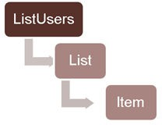
function List({ list }) { if (!list) {  return null;  }  if (!list.length) {  return <p>Sorry, the list is empty.</p>;  } | function Item({ item }) {  return (  <li>  {item.firstName} {item.lastName}  </li>  );  }  export default ListUsers;
return (
<ul>
{list.map(item => (
<Item key={item.id} item={item} />
))}
</ul>
)}



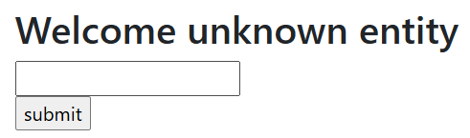
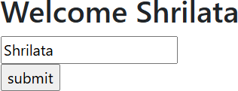
import React, { useState } from 'react' function ConditionalRenderingDemo() {

const [uname, setUname] = useState('')
const [submitted, setSubmitted] = useState(false)

let handleChange = (event) => { setUname(event.target.value)
}

let handleClick = () => { setSubmitted(true)
}
Using ternery operator

return (
<div>
<h2>Welcome {submitted? uname:'unknown entity'}</h2>
<input onChange={handleChange} value={uname} /><br />
<input type="button" value="submit" onClick={handleClick} />
</div>
)
}
export default ConditionalRenderingDemo

- Using conditions with logical && operator
import ListBooks from "./ListBooks";

const BookInfo = () => { const books = [
{id:101, name:"Core Java", author:"author1", price:400},
{id:102, name:"Core Servlets", author:"author2", price:450},
{id:103, name:"Core JSP", author:"author2", price:300},
{id:104, name:"Spring Basics", author:"author3", price:500},
]
return(
<div>
<ListBooks books={books} />
</div>
);
}
export default BookInfo;

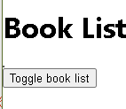
import { useState } from "react"; function ListBooks(props) {

const [show, setShow] = useState(false)
const [books, setBooks] = useState(props.books)

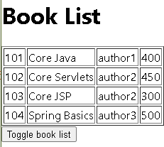
const btnHandler = () => { setShow(!show);

}
return (
<div>
<h1>Book List</h1>
<table border="1">
{show && books.map(book => (<tr>

Using Inline Boolean
Condition

<td>{book.id}</td><td>{book.name}</td>
<td>{book.author}</td><td>{book.price}</td>
</tr>)
) }
</table>
<button onClick={btnHandler}>Toggle book list</button>
</div>
);
}
export default ListBooks;
We can use the logical && operator along with some condition to decide what will appear in output based on whether the condition evaluates to true or false.
If the condition provided in the above syntax evaluates to True then the elements right after the && operator will be a part of the output and if the condition evaluates to false then the code within the curly braces will not appear in the output.

function ListBooks(props) {

const [show, setShow] = useState(false)
const [books, setBooks] = useState(props.books)

const btnHandler = () => { setShow(!show);
}
return (
<div>
<h1>Book List</h1>
<table border="1">
{ show ? books.map(book =>
(<tr>

Using ternery operator

<td>{book.id}</td><td>{book.name}</td>
<td>{book.author}</td><td>{book.price}</td>
</tr>)
) : null }
</table>
<button onClick={btnHandler}>Toggle book list</button>
</div>
);
}
export default ListBooks;

import { useState } from "react/cjs/react.development"; function ListBooks(props) {
const [show, setShow] = useState(false)
const [books, setBooks] = useState(props.books)

const btnHandler = () => {
Using a function
setShow(!show);
}
const showBooks = () => {
const bookdata = books.map(book => (<tr>
<td>{book.id}</td><td>{book.name}</td>
<td>{book.author}</td><td>{book.price}</td>
</tr>))
if (show)

return (bookdata); else
return null
}

}
return (
<div>
<h1>Book List</h1>
<button onClick={btnHandler}>Toggle book list
</button>
{showBooks()}
</div>
);

export default ListBooks;

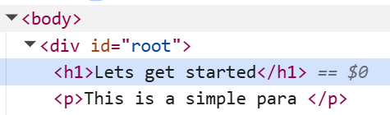
React Fragments
function App() { return (
<>
<h1>Lets get started</h1>
<p>This is a simple para </p>
</>
)
}
import { Fragment } from 'react' function App() {
return (
<Fragment>
<h1>Lets get started</h1>
<p>This is a simple para </p>
</Fragment>
)
}
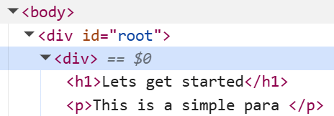
function App() { return (
<div>
<h1> Hi, welcome to React</h1>
<p>This is a simple para </p>
</div>
);
}

CLASS-BASED COMPONENTS

Class-based components : Examples

Functional components are regular javascript functions which return renderable results (typically JSX)
const HelloComponent = () => {
return <h3>Hello, welcome user!!</h3>
}
export default HelloComponent;

Class based components are defined using Javascript classes where a render method defines the to-be-rendered output
class HelloComponent extends Component{ render(){
return (<h3>Hello, welcome user!!</h3>)
}
}
export default HelloComponent;

Class-based components : passing into props

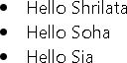
import React, {Component} from 'react';
import User from './User'

const users= [
{ id: 'u1', name: 'Shrilata' },
{ id: 'u2', name: 'Soha' },
{ id: 'u3', name: 'Sia' },
];

class Users extends Component{ render(){
return(
<div>
<User name={users[0].name} />
<User name={users[1].name} />
<User name={users[2].name} />
</div>
function App() {
return (
<div className="App">
<h1> Welcome to React</h1>
<Users />
</div>
);
}

); import './User.css';
} import React, {Component} from 'react';
}

export default Users;
class User extends Component{
render(){
return (<li>Hello {this.props.name}</li>);

}
};
export default User;

React State : Class-based component
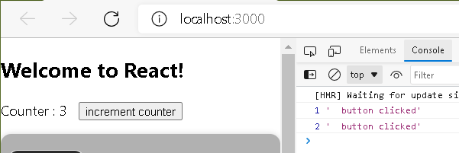
import React, {Component} from "react"; class StatefulComponent extends Component{
state = {counter:1 }

btnHandler = () => {
class App extends Component {
render() {
return (
<div>
<StatefulComponent />
</div>
)}
}

constructor(){ super();
this.state = {counter:1}
}

this.setState({counter:this.state.counter+1}) console.log(this.state.counter, " button clicked")
}
render(){
return(
<div>
Counter : {this.state.counter} &nbsp;&nbsp;
<button onClick={this.btnHandler}>increment counter</button>
</div>
);
}
}
export default StatefulComponent;

React State : Example

import React,{Component} from 'react'; class statefulComponent extends Component{
state = {
name: "Shrilata",
Unlike useState, its so easy to group state together in class component
email: "shrilata@gmail.com", address:"Pune"
}
render(){
return(
<div>
<h3>Name : {this.state.name}</h3>
<h3>Email : {this.state.email}</h3>
<h3>Address : {this.state.address}</h3>
</div>
);
}
}
export default statefulComponent;

LIFECYCLE EVENTS

Lifecycle methods
- Lifecycle methods are pre-defined functions in React defined for components
- A React component undergoes 3 phases in its lifecycle - mounting, updating, and unmounting.
  - Each React lifecycle phase has a number of lifecycle methods that you can override to run code at specified times during the process.
  - These are popularly known as component lifecycle methods.
  - Each phase has specific methods responsible for a stage in a component's lifecycle.
  - These methods are technically particular to class-based components and not intended for functional components.
  - However, since the concept of Hooks was released in React, you can now use abstracted versions of
these lifecycle methods when you’re working with functional component state.

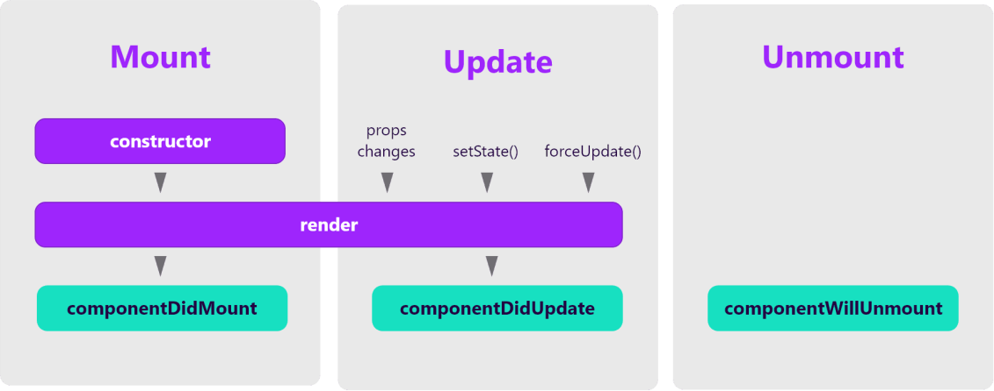
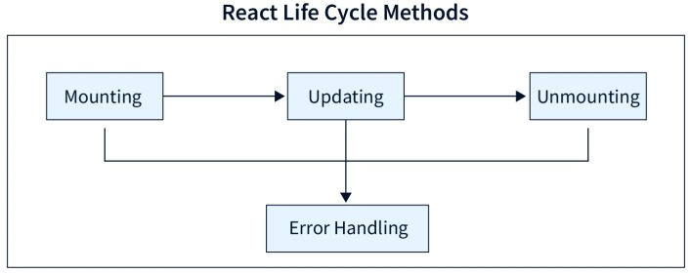

Lifecycle methods : mounting phase
- The mounting phase refers to the phase during which a component is created and inserted to the DOM.
- The following methods are called in order.
  - constructor() : This lifecycle method is the first one that is called and is usually where you will set the state of your component.
  - render(): You have this method for all the components created; it is the only required method within a class component in React. This method is in charge of displaying HTML markup to the user.
  - componentDidMount(): This method is called right after the react component is mounted on DOM; ie it
is called right after render method executed for the first time
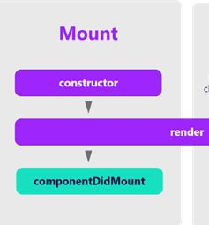
  - Here we can make API call, for eg, interact with dom or perform any ajax call to load data.

class HelloComponent extends Component{
constructor(){
super(); console.log("Component constructor")
}
componentDidMount(){
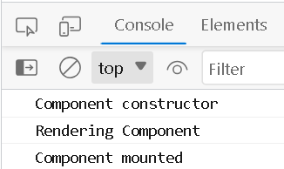
console.log("Component mounted")
}
render(){
console.log("Rendering Component") return <h3>Hello</h3>
}}

Lifecycle methods : updating phase
- An update is caused by props or state changes.
  - The component is re-rendered whenever a change is made to react component’s state or props ; ie the component is updated
  - For example, you enter something in the textbox, so the state properties are updated.

- Some methods and order in which they are called:
  - shouldComponentUpdate(): executed before rendering data if any changes are updated in state & props. Returns true by default, if false, component will not re-render on updating the existing value of state & props
  - render() : already seen
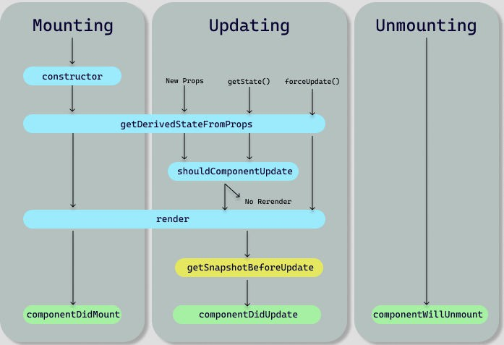
  - componentDidUpdate() : executes after the real DOM is updated

getDerivedStateFromProps() :available in React
16.3 and later versions. Is invoked during the
mounting and updating phase of a component.

During the mounting phase, it is called after the constructor and before render(). This method is called for every render cycle and provides an opportunity to update the component's state based on changes in props before the initial render.

Lifecycle methods : unmounting phase
- UnMounting: this state comes into the picture when the Component is not required or removed.
- Following are the methods available in unmount state:
  - ComponentWillUnmount(): is called just before the component is unmounted or destroyed.
  - Unmounting is simply removing the component from the DOM so that we cannot modify its state or rerender it.

class App extends React.Component {
componentDidMount() {
//the event listener is added element.addEventListener()
}

componentWillUnmount() {
//the event listener is removed element.removeEventListener()

example : we put an event listener inside the componentDidMount() method and then remove that event listener inside the componentWillUnmount() method.

}
}

ERROR BOUNDARIES

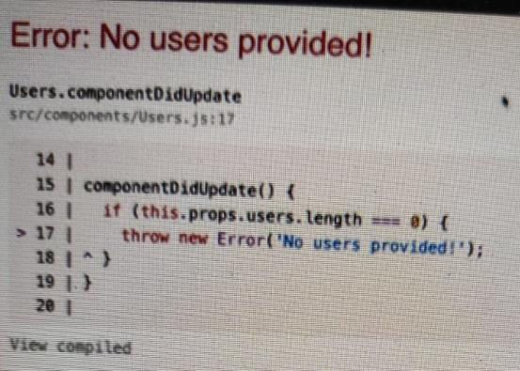

Using Error Boundaries
class HelloComponent extends Component{ render(){
let rnd = Math.random();
if(rnd > 0.7){
throw new Error("Something went wrong");
class Users extends Component{ componentDidUpdate(){
if(this.props.users.length == 0)
throw new Error("No users provided")
}
...

}
return <h3>Hello {rnd}</h3>
}
}

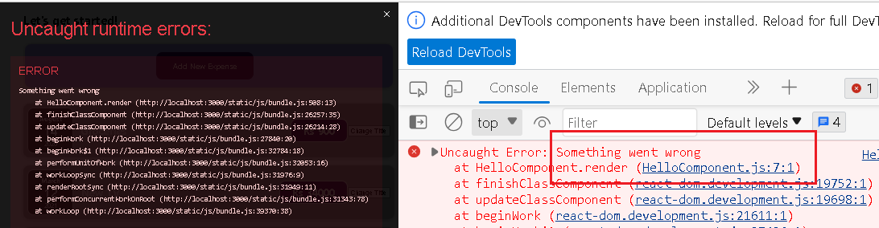
- By default, if your application throws an error during rendering, React will remove its UI from the screen.
- A JavaScript error in a part of the UI shouldn’t break the whole app.
- To solve this problem for React users, React 16 introduces a new concept of an “error boundary”.


Error Boundaries
Error boundaries are like a JavaScript catch {} block, but for components.
- Error boundaries were introduced in React v16
  - To use them, you need to define a class component with either or both of the following lifecycle methods: getDerivedStateFromError() or componentDidCatch().
  - componentDidCatch(): This method is used for logging error information.

import React, {Component} from 'react'; class ErrorBoundary extends Component{  state = {  hasError:false, errorMessage:''  }  componentDidCatch = (error, info) => { this.setState({hasError:true, errorMessage:error});  } |  | Use it like this:  <ErrorBoundary>  <Artists />  </ErrorBoundary>
render(){  if(this.state.hasError)  return <h1>{this.state.errorMessage}</h1> else  return this.props.children  }  }  export default ErrorBoundary; | 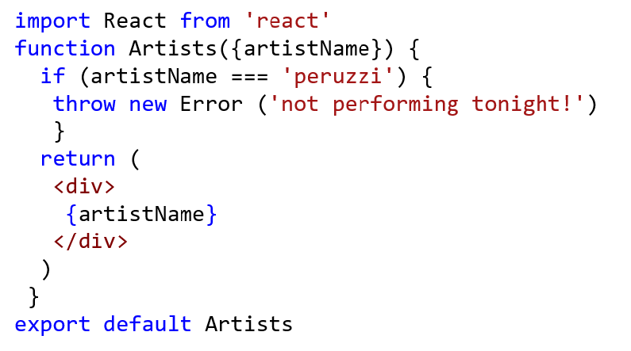

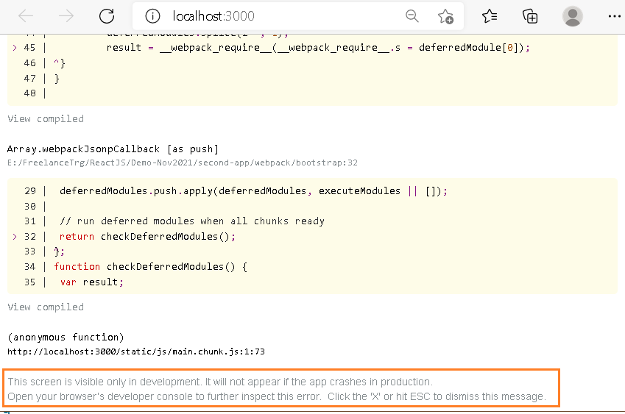

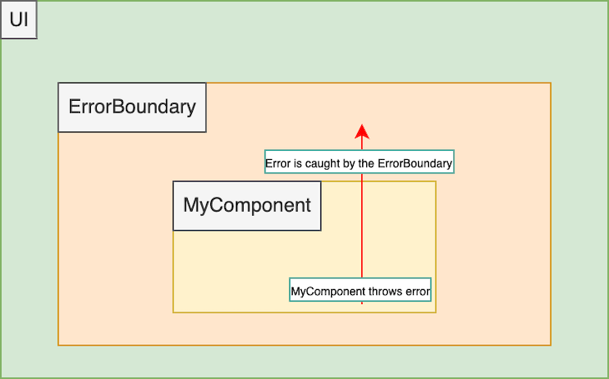
Using Error Boundaries
- Where to place these error boundaries?
  - They can be set up around the entire app or
individual components for more granular control.

function App() { return (
<div className="App">
<h1> Welcome to React</h1>
<ErrorBoundary >
<Person />
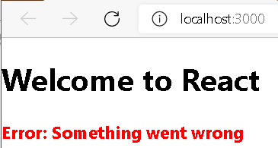
</ErrorBoundary>
</div>
);
}

USEEFFECTS IN FUNCTIONS

Understanding useEffect() hook
- In React.js, managing side effects, such as fetching data,
subscriptions, and manipulating the DOM, is a crucial aspect of building modern and dynamic web applications.
- The useEffect() hook plays a central role in handling side effects and lifecycle events in functional components.

- How is working with useEffect() different from working with the lifecycle methods of class-based components?
  - lifecycle methods give components a predictable structure.
  - The code is more explicit (in contrast to effects), so developers can directly spot the relevant parts (e.g., componentDidMount) in terms of performing tasks at particular lifecycle phases (e.g., on component unmount).

- useEffect() allows functional components to perform side effects, such as data fetching,
subscriptions, or DOM manipulations, after rendering.
  - With useEffect, developers can perform side effects without writing class components and managing lifecycle methods like componentDidMount, componentDidUpdate, and componentWillUnmount.
useEffect() is a React hook that’s lets you run side effects

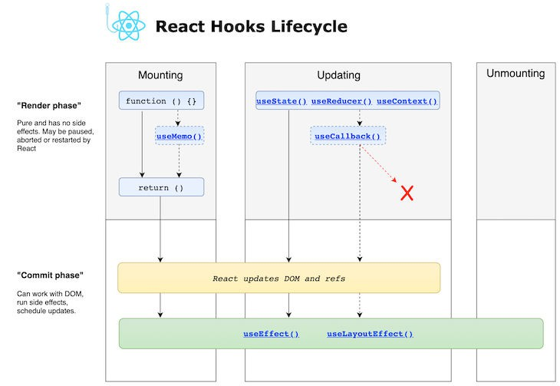

- Effects defined with useEffect are invoked after render.
- To be more specific, it runs both after the first render and after every update.
- In contrast to lifecycle methods, effects don’t block the UI because they run asynchronously.
- Unlike class components, you do not do something after the component is mounted; you do something after the component is first presented to the user.

- Hooks force you to think more from the user’s perspective.

- Syntax:
useEffect(() => {
//Runs on every render
});
- import { useEffect } from 'react';
- useEffect( ()=>{} , [dependencies] )

- The useEffect hook takes two arguments: a callback function and an optional dependency array.
- The callback function represents the side effect logic, while the dependency array controls
when the side effect should run or update.

- The following steps are carried out when executing an effect:
  - Initial render/mounting: When a functional component that contains a useEffect Hook is initially rendered, the code inside the useEffect block runs after the initial render of the component.
  - This is similar to componentDidMount class components

  - Subsequent renders: You can pass a dependency array as the second argument to the useEffect Hook.
  - This array contains variables or values that the effect depends on. Any change in these variables will
re-render the component.
  - If no dependency array is given, the effect will run on every render

  - Cleanup function: You can also run an optional cleanup function inside the effect.
  - It is used to clean up any resources or subscriptions created by the effect when the component is unmounted or when the dependencies change

  - Unmounting: If a cleanup function is present, it is run and then the component is unmounted from the DOM


//No dependency passed:

useEffect(() => {
//Runs on every render
});

- Using setTimeout() to count 1 second after initial render
import { useState, useEffect } from "react";

function Timer() {
const [count, setCount] = useState(0);

useEffect(() => { setTimeout(() => {
setCount((count) => count + 1);
}, 1000);
});

return <h1>I have rendered {count} times!</h1>;
}
export default Timer
- But it keeps counting even though it should only count once!
- Why? useEffect runs on every render. That means that when the count changes, a render happens, which then triggers another effect.

- How to control when side effects run?
  - Always include the second parameter which accepts an array. We can pass dependencies to useEffect in this array

//An empty array:

useEffect(() => {
//Runs only on the first render
}, []);

const EffectDemo = () => {

const [choice, setChoice] = useState('posts')

return (
<div>
<div>
<button className="btn btn-primary"
onClick={() => setChoice('posts')}>Posts</button>
<button className="btn btn-primary"
onClick={() => setChoice('users')}>Users</button>
<button className="btn btn-primary"

onClick={() => setChoice('comments')}>Comments</button>
</div>
<h2>{choice}</h2>
</div>
)
}
export default EffectDemo

const EffectDemo = () => {
const [choice, setChoice] = useState('posts') useEffect(()=>{
fetch(`https://jsonplaceholder.typicode.com/${choice}`)
.then(response => response.json())
.then(json => console.log(json))
}, [choice])
return (
<div>
<div>
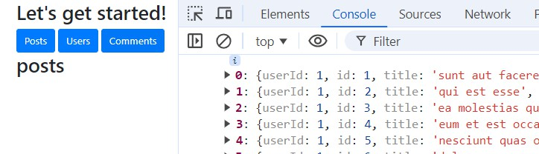
<button …
</div>
<h2>{choice}</h2>
</div>
)
}
export default EffectDemo

const EffectDemo = () => {

const [choice, setChoice] = useState('posts') const [items, setItems] = useState([])

useEffect(()=>{ fetch(`https://jsonplaceholder.typicode.com/${choice}`)
.then(response => response.json())
.then(json => setItems(json))
}, [choice])

return (
<div>
<div>
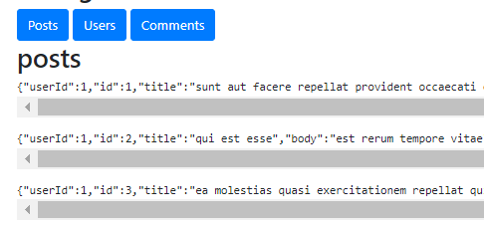
<button ...> ...
</div>
<h2>{choice}</h2>
{
items.map(item => {
return <pre>{JSON.stringify(item)}</pre>
})
}
</div>)

- Same code as previous, but with async and await

import { useEffect, useState } from "react"

const EffectDemo = () => {

const [choice, setChoice] = useState('posts') const [items, setItems] = useState([])

useEffect(() => {
async function fetchData() { const response =
await fetch(`https://jsonplaceholder.typicode.com/${choice}`) const data = await response.json()
setItems(data)
}

fetchData()
}, [choice])

...

- Uncontrolled component and Controlled component are terms used to describe React components that render HTML form elements.
  - Every time you create a React component that renders an HTML form element, you are creating one of
those two.
  - Controlled component are those whose form input fields are handled via state by React
  - Uncontrolled component are those that are handled directly via DOM.

- A controlled component is bound to a value, and its adjustments will be handled in code by using event-based callbacks.
  - Here, the input form variable is handled by the react itself rather than the DOM.
  - In this case, the mutable state is maintained in the state property and modified using setState().

- Controlled components have functions which regulate the data that occurs at each on
Change event.
  - This data is subsequently saved in the setState() method and updated. It helps components manage the elements and data of the form easier.

- “uncontrolled” form inputs: React doesn’t track the input’s state.
  - The DOM handles the data
  - Uncontrolled components are inputs that do not have a value property.
  - In opposite to controlled components, it is the application's responsibility to keep the component state and the input value in sync.
  - To create a uncontrolled component, we can use JavaScript. But React allows us to create a “ref”
(reference) to associate with an element, giving access to the underlying DOM node

- “ref is used to receive the form value from DOM.
  - To enable this, React allows us to create a “ref” (reference) to associate with an element, giving access
to the underlying DOM node.
  - Refs provide a way to access DOM nodes or React elements created in the render method.
  - In class component, Refs are created using React.createRef() and attached to React elements via the
ref attribute.
    - Refs are commonly assigned to an instance property when a component is constructed so they can be referenced throughout the component.
  - In function components, refs are created using useRef() hook

class MyComponent extends React.Component { constructor(props) {
super(props);
this.myRef = React.createRef();
}
render() {
return <div ref={this.myRef} />;
}
}
let SimpleUncontrolledForm = () => { let unameRef = useRef("")
return (
<form onSubmit={submitHandler}>
Username : <input ref={unameRef} />
...
}

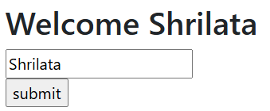
import React, { useRef, useState } from 'react' function RefDemo() {
const uname = useRef()

const [username, setUsername] = useState('')

let handleClick = () => {
setUsername(uname.current.value)
}

return (
<div>
<h2>Welcome {username? username:'unknown entity'}</h2>
<input ref={uname}/><br />
<input type="button" value="submit" onClick={handleClick} />
</div>
)
}
export default RefDemo

import React, {Component} from 'react'; class SimpleForm extends Component {
constructor(props) { super(props);
// create a ref to store the DOM element this.nameEl = React.createRef();
}

handleSubmit = (e) => { e.preventDefault(); alert(this.nameEl.current.value);
}

render() { return (
<form onSubmit={this.handleSubmit}>
<label>Name:
<input type="text" ref={this.nameEl} />
</label>
<input type="submit" name="Submit" />
</form>
- You initialize a new ref in the constructor by calling React.createRef, assigning it to an instance property so it’s available for the lifetime of the component.
- In order to associate the ref with an input, it’s passed to the element as the
special ref attribute.
- Once this is done, the input’s underlying DOM node can be accessed via this.nameEl.current.

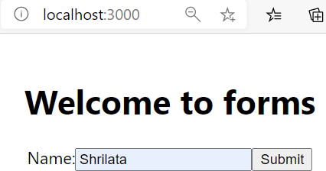
)
}
}
export default SimpleForm;

class LoginForm extends Component {
constructor(props) { super(props);
this.nameEl = React.createRef(); this.passwordEl = React.createRef();

Another example : Login form

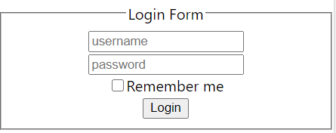
this.rememberMeEl = React.createRef();
}
handleSubmit = (e) => { e.preventDefault(); const data = {
username: this.nameEl.current.value, password: this.passwordEl.current.value,
rememberMe: this.rememberMeEl.current.checked,
}
console.log(data)
}
render(){ return (
<form onSubmit={this.handleSubmit}>
<fieldset><legend>Login Form</legend>
<input type="text" placeholder="username" ref={this.nameEl} /><br></br>
<input type="password" placeholder="password" ref={this.passwordEl} /><br></br>
<label><input type="checkbox" ref={this.rememberMeEl} />Remember me
</label><br></br>
<button type="submit" className="myButton">Login</button>
</fieldset>
</form>
);
}}

COMPOSITION VS. INHERITANCE

Composition over Inheritance
- Composition and inheritance are the approaches to use multiple components together in React.js .
- This helps in code reuse.
- React recommends using composition instead of inheritance as much as possible and inheritance should be used in very specific cases only.
- Composition works with functions as well as classes both.

- Composition is a code reuse technique where a larger object is created by combining
multiple smaller objects

class UserNameForm extends Component {
render() {
return (
<div><input type="text" /></div>

Inheritance

)}
}
import { CreateUserName, UpdateUserName } from ...

function App() { return (
<div className="App">
<CreateUserName />
<UpdateUserName />
export class CreateUserName extends UserNameForm {
render() {
const parent = super.render(); return (
<div>{parent}
<button>Create</button>
</div>
)}
}
export class UpdateUserName extends UserNameForm { render() {
const parent = super.render(); return (
<div>{parent}
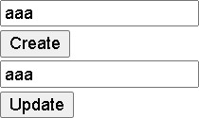
<button>Update</button>
</div>
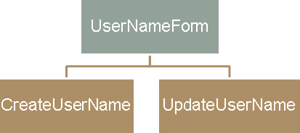
)}
}

Composition
CreateUserName1 UserNameForm1
class UserNameForm1 extends Component { render() {
return (
<div><input type="text" /></div>
)}
UpateUserName1 UserNameForm1
}
export class CreateUserName1 extends Component { render() {
return (
<div>< UserNameForm1 />
<button>Create</button>
</div>
)}
}
export class UpdateUserName1 extends Component { render() {
return (
<div><UserNameForm1 />
<button>Update</button>
</div>
)}
}

Composition versus inheritance

- In Inheritance, the components are tightly coupled, and therefore any change in the parent component can bring unexpected consequences to its descendant child components.
- Moreover, it causes the complete restructuring of the component tree.
- Compositions integrate components and keep them loosely coupled.
- That helps to manage future requirements in
the application.

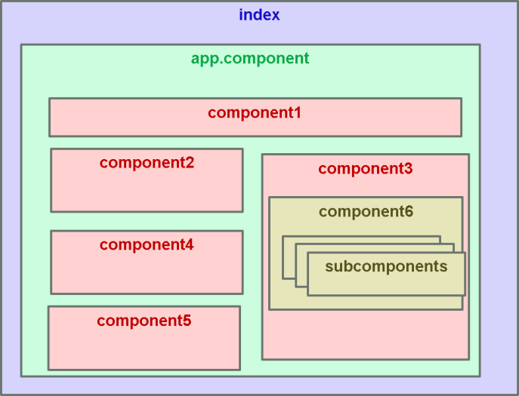
- Component composition in React involves combining smaller, independent components to create complex UIs.
- Each sub-component can contain further components,
enhancing code readability.
- This process breaks down the UI into manageable pieces, aiding traceability, scalability, and maintenance.

class App extends Component { state = {
date:new Date()
...
}
...
return (
<div className="container">
<NewsHeader className="news" subject="Sports" date={this.state.date.toString()} />
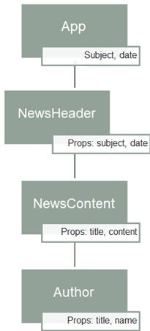

const newsHeader = (props) => {
return(
<div>
<h1>News for {props.date}</h1>
<h2>News Heading : {props.subject}</h2>
title="Content Title-1" content="Lots of Content-1" /> title="Content Title-2" content="Lots of Content-2" /> title="Content Title-3" content="Lots of Content-3" />
<NewsContent
<NewsContent
<NewsContent

const newsContent = (props) => { return(
<div>
const author = (props) => { return(
<h6>Author for {props.title} - {props.name}</h6>

{/*complex code that filters out news based on subject*/}
<h4><b><i>News Title {props.title}</i></b></h4>
<h4>News Content : {props.content}</h4>
<Author title={props.title} name="Shrilata" />

CONTEXT API

function Component1() {
const [user, setUser] = useState("Shrilata T");

return (
<>
<h1>{`Hello ${user}!`}</h1>
<Component2 user={user} />
</>
);
}

function Component2({ user }) {
return (
<>
<h1>Component 2</h1>
<Component3 user={user} />
</>
);
}

function Component3({ user }) { return (
<>
<h1>Component 3</h1>
<Component4 user={user} />
</>
);
function Component4({ user }) { return (
<>
<h1>Component 4</h1>
<Component5 user={user} />
</>
);
}

function Component5({ user }) { return (
<>
<h1>Component 5</h1>
<h2>{`Hello ${user} again!`}</h2>
</>

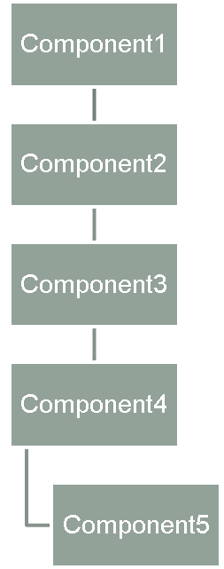
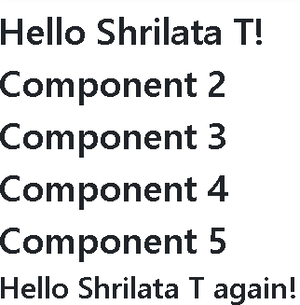
} );
}
Even though components 2-4 did not need the state, they had to pass the state along so that it could reach component 5.

- The main purpose of Contex API is to avoid props drilling.
- Context is designed to share data that can be considered “global” for a tree of React
components, such as the current authenticated user, theme, or preferred language

- Context API consists of two main components: the context provider and the context consumer.
  - The provider is responsible for creating and managing the context, which holds the data to be shared between components.
  - The consumer is used to access the context and its data from within a component.
  - This avoids the need to pass the information down through props, making your code more efficient and easier to manage.

- Store the state in a Context value in the common ancestor component (called the Provider Component), and access it from as many components as needed (called Consumer Components), which can be nested at any depth under this ancestor.
  - React.js takes care of all the magic behind the scenes to make this work.

- Primary situations where the React Context API really shines are:
  - When your state needs to be accessed or set from deeply nested components.
  - When your state needs to be accessed or set from many child components

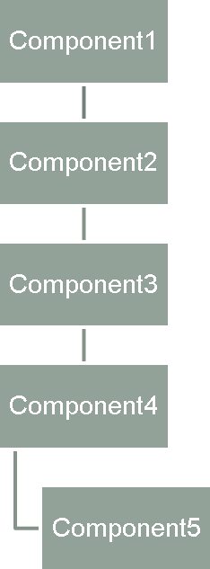
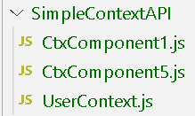

Demo

- Step 1 : Create context obj
// UserContext.js
import React from 'react’;
export default React.createContext();
When React renders a component that subscribes to this Context object it will read the current context value from the closest matching Provider above it in the tree

There are two ways to assign a state to our context.
  - By assigning default values when our context object is created.
  - Use Provider component in parent component by using value to set state in our context object.
  - For our example, we will assign a default value (“ ”) while creating our context

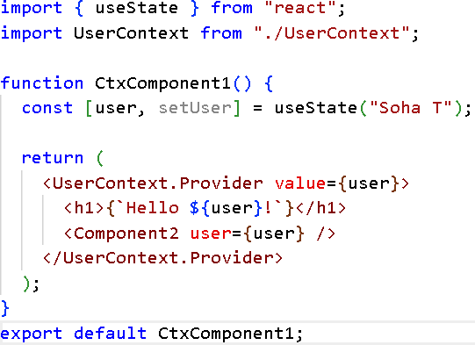
    - Step-2: wrap the components that need access to the shared data with a Provider component.
      - The Provider component accepts a "value" prop that holds the shared data, and any component that is a child of the Provider component can access that shared data.
      - It's important to note that the Provider component should be wrapped around the top-level component in an application to ensure that all child components have access to the shared data.

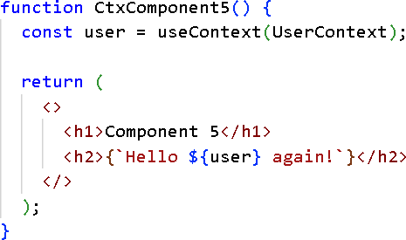
- Step-3 :In order to use the Context in a child component, we need to access it using the useContext Hook.
  - First, include the useContext in the import statement
  - Then you can access the user Context in
all components:

REDUX

Because state management can be hard

State

When we discuss state, there are 3 types of state:
  - Local state : state that belongs to a single component, eg listening to user input in a input field,
toggling a “show more” details field, state for our error boundary class etc
  - Cross component state : state that affects multiple components, eg open/closed state of a modal overlay, ie code to open is model is not inside the modal, though code to close and dispose modal may lie within. For this we might have to do “prop-drilling”.
  - App-wide state : state that affect the entire app, or state that affects most of the components of app. Eg user authentication status. Eg based on user authentication, some of the components will change their navigation bar etc.

- React Context and Redux – both are meant to resolve cross component or app-wide state.
- As an application grows, it becomes difficult to keep it organized and maintain data flow. That is where Redux comes to the rescue

state = {
hasError:false, errorMessage:''
}
class LoggingComponent extends Component { constructor() {
this.state = { isLoggedIn: true }
}
}

Terms
- Store
- Reducer : simply a kind of function that will change state of store
- A reducer receives the current state and an action object, decides how to update the state if necessary, and returns the new state:
Input
Old state + Dispatched action
Output
New state Object
Reducer function
const myreducer = (state, action) => newState

- useSelector() : a react hook that will allow us to fetch from the store
- useDispatch() : To update something in store, I need to call reducer. But I cannot call reducer directly, it would break the flow.
- I will use the useDispatch() hook to send an action to reducer to update state. The useDispatch is used to call a very specific reducer
- An action is a plain JavaScript object that has a type field. You can think of an action as
an event that describes something that happened in the application.

Simple Node Redux project to understand the various terms
  - Create new folder
  - npm init –y
 | //step-4 : subscribe to the store store.subscribe(counterSubscriber);
//step-1 : create reducer  import { createStore } from "redux"; | //step-5 : create actions
const reducer = (state = {count:0}, action) => { switch (action.type) {  case "INCREMENT":  return { count: state.count + 1 }; case "DECREMENT":  return { count: state.count - 1 }; default:  return state; | const increment =  () => ({ type: "INCREMENT" });  const decrement =  () => ({ type: "DECREMENT" });  //step-6 : dispatch actions store.dispatch(increment()); store.dispatch(decrement());
}
};
//step-2 : create store
const store = createStore(reducer);
//step-3 : create subscriber
const counterSubscriber = () => {
console.log("State changed:", store.getState());
};

  - npm install redux

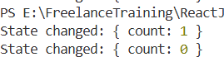

  - Step-1 : Create a Redux app using Vite
  - Step-2: Install : npm install redux react-redux
    - Copy all contents of component.zip into components folder
  - Step-3 : Create a folder called “store” and a index.jsx in it.
//src/store/index.js
import { createStore } from "redux";

const initialState = { count: 0 };

const reducer = (state = initialState, action) => { switch (action.type) {
case "INCREMENT":
return { ...state, count: state.count + 1 };
case "DECREMENT":
return { ...state, count: state.count - 1 }; default:
return state;
}
};
//main.jsx
import {Provider} from 'react-redux' import store from './store/index.js'
createRoot(document.getElementById(' root')).render(
<StrictMode>
<Provider store={store}>
<App />
</Provider>
</StrictMode>
)

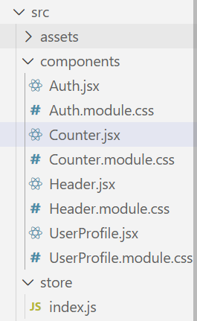
const store = createStore(reducer);
export default store;
Once the store is created, we can make it available to our React components by putting a React Redux <Provider> around our application in src/index.js.
Import the Redux store we just created, put a <Provider> around your <App>, and pass the store as a prop


import classes from './Counter.module.css'; import { useSelector } from 'react-redux';

const Counter = () => {
const counter = useSelector((state) => state.counter); const toggleCounterHandler = () => {};
return (
<main className={classes.counter}>
<h1>Redux Counter</h1>
<div className={classes.value}>{counter}</div>
<button onClick={toggleCounterHandler}>Toggle Counter</button>
</main>
);
};
export default Counter;

- There are many ways to fetch data from an external API in React:
  - Using fetch() API
  - Using axios library
  - Using async / await syntax
  - Using a Custom React Hook (useFetch)
  - Using the React Query Library

  - Egs of ready-to-use api’s for json data
  - https://jsonplaceholder.typicode.com/users
  - https://randomuser.me/api/
  - https://www.anapioficeandfire.com/api/books

import React, { Component } from 'react' class FetchData extends Component {
constructor(props) { super(props); this.state = {
users: [], dataLoaded: false
};
}
componentDidMount() {
fetch("https://jsonplaceholder.typicode.com/users")
.then((res) => res.json())
.then((json) => { this.setState({
users: json, dataLoaded: true
});
})
}

Fetch data from an api in react : continued

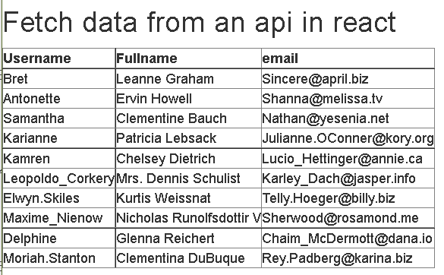
render() {
const { dataLoaded, users } = this.state;
if (!dataLoaded) return <div>
<h1> Loading...please wait some time.... </h1> </div>;

return (
<div className="App">
<h2> Fetch data from an api in react </h2>
<table border="1">
<tr><th>Username</th><th>Fullname</th><th>email</th></tr>
{users.map(user => (
<tr key={user.id} >
<td>{user.username}</td>
<td>{user.name}</td>
<td>{user.email}</td>
</tr>
))
}
</table>
</div>
);
}
}
export default FetchData

REACT ROUTER

React Router v6

What is React Router
- React Router enables "client side routing".

  - In traditional websites, the browser requests a document from a web server, downloads and evaluates CSS and JavaScript assets, and renders the HTML sent from the server. When the user clicks a link, it starts the process all over again for a new page.

  - Client side routing allows your app to update the URL from a link click without making another request for another document from the server. Instead, your app can immediately render some new UI and make data requests with fetch to update the page with new information.

  - This enables faster user experiences because the browser doesn't need to request an entirely new document or re-evaluate CSS and JavaScript assets for the next page. It also enables more dynamic user experiences with things like animation.
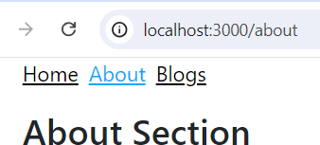

Setting up app
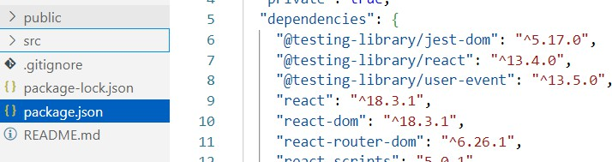
- Step-1: Create React App doesn't include page routing. Hence we need to install React Router in our application:
- npm install react-router-dom

- Step-2 : To configure React router, navigate to the index.js file, import BrowserRouter
from the react-router-dom package and wrap it around App component as follows:
import { BrowserRouter } from 'react-router-dom';

const root = ReactDOM.createRoot(document.getElementById('root')); root.render(
<React.StrictMode>
<BrowserRouter >
<App />
</BrowserRouter>
</React.StrictMode>
);

const About = () => {
return <h2> About Section</h2>
}
export default About
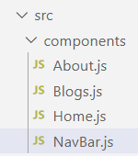
- Step-3 : Create the components we want to navigate:
const Home = () => {
return <h2> Home Section</h2>
}
export default Home

const Blogs = () => {
return <h2> Blogs Section</h2>
}
export default Blogs

  - Step-4 : Create a standard Navigation bar component that can be used to navigate inside our application.
NavLink component from react-router- dom is a special component that helps you navigate different routes using the to prop.
import { NavLink } from "react-router-dom";

const NavBar = () => { return (
<nav>
<ul>
<li>
<NavLink to="/">Home</NavLink>
</li>
<li>
<NavLink to="/about">About</NavLink>
</li>
<li>
<NavLink to="/blogs">Blogs</NavLink>
</li>
</ul>
</nav>
);
};
The NavLink component also knows whether the route is currently "active" and adds a default active class to the link.
We can use this class in our CSS to
define some styling for active links
/*index.css */
ul li a {
color: #000;
}
ul li a:hover { color: #00a8ff;
}
ul li a.active {
color: #00a8ff;
}

Setting up the App.js
function App() { return (
<div className="App">
<NavBar />
...
- Step-5 : use the Navbar component inside our App
- Step-6: Define/configure our routes
- An application can have any number of <Routes>
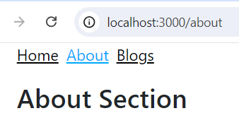
import { Route, Routes } from 'react-router-dom'; function App() {
return (
<div className="App">
<NavBar />
<Routes>
<Route path="/" element={<Home />} />
<Route path="/blogs" element={<Blogs />} />
<Route path="/about" element={<About />} />
</Routes>
</div>
);
}
We imported Routes and Route components from react-router-dom Used them to declare the routes we want.
All Routes are wrapped in the Routes tag, and these Routes have two major properties:

path: identifies the path we want users to take to reach the set component.
When we set the path to /about, for example, when the user adds /about to the URL link, it navigates to that page.

element: contains the component that we want the set path to load.

REACT AXIOS

Axios
- Many projects on the web need to interface with a REST API at some stage
- Axios is a lightweight HTTP client based on the $http service within Angular.js v1.x and is similar to the native JavaScript Fetch API.
import axios from 'axios';
const baseUrl = 'http://localhost:8080/course/courses'
class CourseService{ getCourses(){  return axios.get(baseUrl)  }  getById(id){  return axios.get(baseUrl+"/"+id)  }  updateCourse(course){  return axios.put(baseUrl+"/"+course.id,course) | - Axios is promise-based, which gives you the ability to take advantage of JavaScript’s async and await for more readable asynchronous code.  - There’s built-in client-side protection against cross-site request forgery.
}
addCourse(course){
return axios.post(baseUrl,course)
}
deleteById(id){
return axios.delete(baseUrl+"/"+id)
}
}
export default new CourseService();

Setting up the app
- Create a new React application
- npx create-react-app course-axios-app
- Install axios :
- npm i axios
- install React Router in our application:
- npm install react-router-dom

- For React router, go to the index.js file, import BrowserRouter from
<BrowserRouter>
<App />
</BrowserRouter>
the react-router-dom package and wrap it around App component

